ND Center for Tobacco Prevention and Control Policy State Workplan Report 2016-2018
Organization Date Completed
Initiative | K-12 Schools | Primary Goal | #1 Prevent Initiation
Objective #2 | By June 30, 2018, the ND Center for Tobacco Prevention and Control Policy comprehensive model tobacco-free school policy will cover 90% of the total student enrollment and be adopted by 90% of the Local Education Agencies (LEA) in each public health unit.
Strategy #1 | 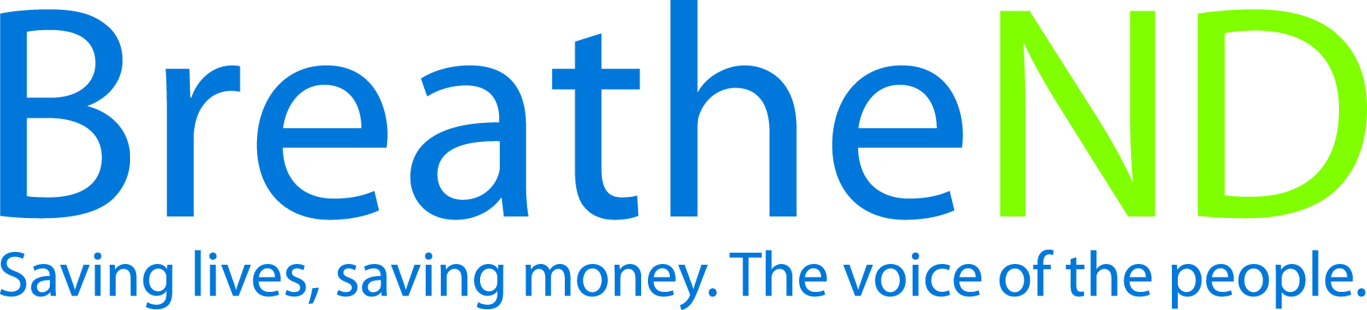  Communicate with School Health Interagency/Community Work Group (SHIW) about the ND Center for Tobacco Prevention and Control Policy (ND Center) comprehensive model tobacco-free school policy (August 2013).
Activities |  | Key achievements and challenges
Meetings attended with SHIW  Input from SHIW documented and distributed to partners |  | Q1:
 |  | Q2:
 |  | Q3:
 |  | Q4:
Strategy #2 | ND Center staff/grantees secure endorsement from other potential partners (i.e., ND United, ND Council of Educational Leaders) in addition to continuing dialogue with the North Dakota School Boards Association (NDSBA) to endorse the ND Center’s comprehensive tobacco-free school policy.
Activities |  | Key achievements and challenges
NDDOH and ND Center staff meet with NDSBA for clarification and endorsement of Center’s comprehensive tobacco-free policy  Endorsement from NDSBA received  Meetings held with other key partners  Endorsements received from key partners |  | Q1:
 |  | Q2:
 |  | Q3:
 |  | Q4:
Strategy #3 | Local public health grantees conduct and coordinate work to facilitate LEA adoption of ND Center comprehensive model tobacco-free policy.
Activities |  | Key achievements and challenges
Signed resolution by Board of Health on file  Meetings held/attended with school administrators and/or school board members  Key community people identified as tobacco-free champions i.e., youth groups, coaches, parents, teachers to promote adoption of policy  Complete annual assessment regarding status tobacco-free policies of LEA  Comprehensive model tobacco-free policy adopted  Communicate policy success through media (website/digital/print/social) |  | Q1:
 |  | Q2:
 |  | Q3:
 |  | Q4:
Strategy #4 | ND Center facilitates efforts in passage of ND Center’s comprehensive model tobacco-free school policy and providing statewide LEA policy status.
Activities |  | Key achievements and challenges
Provide orientation to new local public health unit tobacco prevention coordinators  Provide technical assistance  Maintain/update LEA comprehensive tobacco-free school policy data base and map quarterly  Communicate policy success through media (website/digital/print/social)  Review statewide activities and conduct data analyses for evaluation of objective success |  | Q1:
 |  | Q2:
 |  | Q3:
 |  | Q4:

