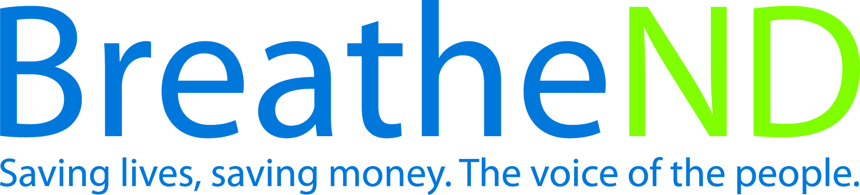
ND Center for Tobacco Prevention and Control Policy State Workplan Report 2016-2018
Organization Date Completed
Initiative | Price Increase | Primary Goal | #1 Prevent Initiation
Objective #1 | By June 30, 2017, increase the price of cigarettes by a minimum amount of $2.00 per pack and a corresponding price increase for all other tobacco products, excluding FDA approved Nicotine Replacement Therapy.
Strategy #1 | Conduct surveys of public, legislators, and candidates to determine level of support.
Activities |  | Key achievements and challenges
Public Survey:  Survey instrument written and approved  Survey conducted  Results analyzed  Report written  Communication/distribution plan written and approved  Communication plan implemented  Legislative/Candidate Survey:  Informal survey instrument written  Formal survey instrument written  Results analyzed and provided to partners/coalitions  Communication/distribution plan written  Communication plan implemented |  | Q1:
 |  | Q2:
 |  | Q3:
 |  | Q4:
Strategy #2 | Develop a policy plan with state and local support (legislative strategy, educational materials including information on all tobacco products, develop and activate coalitions among populations affected by tobacco-related disparities and youth).
Activities |  | Key achievements and challenges
Identify potential partners/coalitions  Obtain support of proposed policy change from potential partners/coalitions  Identify potential state agencies as partners  Identify key policymakers as potential bill co-sponsors, champions and supporters  Meet with key policymakers on legislative objectives  Policy plan written and approved by supporting partners/coalitions  Education materials developed  Public information materials developed  Obtain support from state and local agencies and coalitions  Develop protocols for communication and decision making with partners/coalitions  Other |  | Q1: Developed at one page handout for Local Public Health Units to be used for education regarding price increase policy
 |  | Q2:
 |  | Q3:
 |  | Q4:
Strategy #3 | Introduction of legislative bill to increase all tobacco prices.
Activities |  | Key achievements and challenges
Monitor interim legislative committees  Bill language researched  Bill language drafted  Recruit legislator(s) to serve as prime sponsor(s)  Bill language finalized with legislative sponsors and legislative council  Subsequent sponsors identified and sign on as co-sponsors  Bill filed  Session strategy developed  Bill is passed, signed by Governor, and becomes law |  | Q1:
 |  | Q2:
 |  | Q3:
 |  | Q4:
Strategy #4 | Introduction of legislative bill to define electronic smoking devices as a tobacco product.
Activities |  | Key achievements and challenges
Monitor interim legislative committees  Bill language researched  Bill language drafted  Recruit legislator(s) to serve as prime sponsor(s)  Bill language finalized with legislative sponsors and legislative council  Subsequent sponsors identified and sign on as sponsors  Bill filed  Session strategy developed  Bill passed, signed by Governor and becomes law |  | Q1:
 |  | Q2:
 |  | Q3:
 |  | Q4:
Strategy #5 | Monitor legislative activity and implement policy plan.
Activities |  | Key achievements and challenges
Identify Legislative Committee(s) bill assignment for hearings on committee(s) calendar  Legislative policy/strategies reviewed  Commitment for action from partners/coalitions  Identify additional policy makers  Educational materials used by advocates are developed and/or refined according to use (legislators/public) based on arguments  Education provided to legislators, partners/coalitions and public  Committee hearings attended  Report and analyze opportunities or concerns identified during advocacy work  Key legislative council staff contacted for bill information  State and local agencies, partners/coalitions demonstrate support  Coordinate and provide testimony  Communication protocols implemented  Communication protocols evaluated and changes made |  | Q1:
 |  | Q2:
 |  | Q3:
 |  | Q4:
Strategy #6 | Evaluation of policy plan after session.
Activities |  | Key achievements and challenges
Conduct SWOT analysis  Revise policy plan based on results of analysis |  | Q1:
 |  | Q2:
 |  | Q3:
 |  | Q4:
Strategy #7 | Advocate for federal excise tax increase.
Activities |  | Key achievements and challenges
Contacts made with congressional delegation  Congressional visits conducted |  | Q1:
 |  | Q2:
 |  | Q3:
 |  | Q4:
Strategy #8 | Continued dialogue with tribal leaders and ND state officials (Governor, Tax Commissioner, Attorney General and Indian Affairs Commissioner Executive Director) for consideration of tribal and state tobacco compacts matching or exceeding the stated price of cigarettes by a minimum amount of $2.00 per pack and a corresponding price increase for all other tobacco products excluding FDA approved Nicotine Replacement Therapy.
Activities |  | Key achievements and challenges
Talking points developed  Conversations conducted with ND state officials  Monitor OMB Rev-e-Newsletter for cigarette tax general fund balance  Monitor Tribal and State Relations Committee (legislative and interim)  Investigate findings and take action as a result of Committee work  Meetings held with ND Indian Affairs Commissioner and Standing Rock Chairman  Meetings held with Three Affiliated Tribes, Turtle Mountain and Spirit Lake Chairman or delegated authority  Compacts signed |  | Q1:
 |  | Q2:
 |  | Q3:
 |  | Q4:

