ND Center for Tobacco Prevention and Control Policy State Workplan Report 2016-2018
Organization Date Completed
Initiative | Sustainability | Primary Goal | #4 Build Capacity
Objective #5 | By June 30, 2018, sustain ND comprehensive tobacco prevention and control program in conformance with current CDC recommendations.
Strategy #1 | 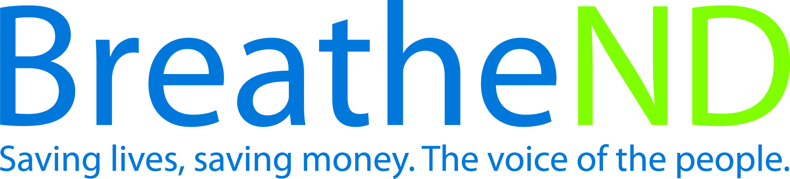  Modify the comprehensive evidence-based tobacco prevention and control program’s state plan based on the independent biennial evaluation recommendations.
Activities |  | Key achievements and Challenges
Review and discuss recommendations with independent evaluator.  Develop objectives, strategies and activities to address the recommendations.  Incorporate changes into the state plan. |  | Q1:
 |  | Q2:
 |  | Q3:
 |  | Q4:
Strategy #2 | Advocate and communicate regularly with Governor, Health Officer, legislative body and partners regarding progress and outcomes of program.
Activities |  | Key achievements and Challenges
Contacts made  Independent biennial evaluation report delivered to Governor and Health Officer |  | Q1:
 |  | Q2:
 |  | Q3:
 |  | Q4:
Strategy #3 | Partners and local public health reinvigorate and mobilize local grassroots coalitions and recruit new local/statewide partners.
Activities |  | Key achievements and Challenges
Increased number of coalition members  Records of coalition meetings |  | Q1:
 |  | Q2:
 |  | Q3:
 |  | Q4:
Strategy #4 | Communicate outcomes, the need for continual funding in light of new and emerging tobacco products/issues and the consequences of not continuing a comprehensive program.
Activities |  | Key achievements and Challenges
Added to media plan  Added to public education strategies  Added to policy maker and leadership communications  Added to appropriate surveys being conducted |  | Q1:
 |  | Q2:
 |  | Q3:
 |  | Q4:
Strategy #5 | Build, practice and strengthen skills in mobilizing partners and effectively communicating with decision makers about policy change at grassroots to support and reinforce “Saving Lives, Saving Money” in communities or at the state level and to effectively counter pro-tobacco influences.
Activities |  | Key achievements and Challenges
Trainings offered  Trainings attended with practice opportunities for communication skills  Self-evaluation reports improvement  Surveys of public and policy makers report support  Reports of countering pro-tobacco influences documented |  | Q1:
 |  | Q2:
 |  | Q3:
 |  | Q4:
Strategy #6 | Examine and modify the comprehensive evidence-based tobacco prevention and control program’s state plan using The Guide to Community Preventive Services.
Activities |  | Key achievements and Challenges
Review and discuss recommendations with independent evaluator  Develop objectives, strategies and activities to address the recommendations  Incorporate changes into the State Plan |  | Q1:
 |  | Q2:
 |  | Q3:
 |  | Q4:

