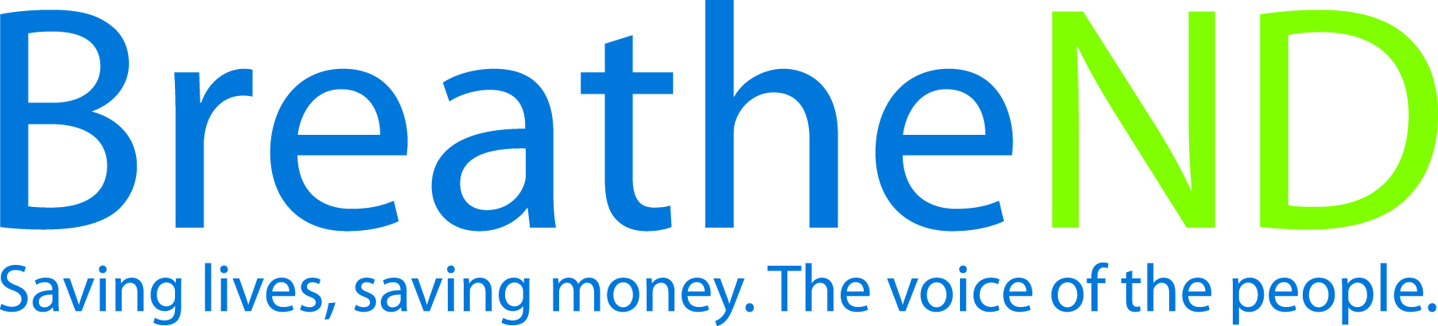
ND Center for Tobacco Prevention and Control Policy State Workplan Report 2016-2018
Organization Date Completed
Initiative | Health Communications | Primary Goal | #4 Build Capacity
Objective #3 | By June 30, 2018, implement effective, ongoing tobacco prevention and control health communication initiatives that focus on changing the broad social norms of tobacco use. The communication initiatives will deliver strategic, culturally appropriate and high-impact earned and paid messages through sustained and adequately funded campaigns integrated into the overall comprehensive North Dakota Tobacco Prevention and Control Plan.
Strategy #1 | Maintain PETF funding from local public health units.
Activities |  | Key achievements and Challenges
LPHU funding received |  | Q1:
 |  | Q2:
 |  | Q3:
 |  | Q4:
Strategy #2 | Educate policy makers, leaders, and the public on: harmful effects of secondhand smoke and tobacco use, costs of tobacco, tobacco industry tactics, benefits of increasing the price of tobacco, cessation, increasing the minimum age of sale for all tobacco products, youth access to tobacco, point of sale strategies and new and emerging products.
Activities |  | Key achievements and Challenges
Earned media plan developed  Earned media plan implemented  Paid media plan developed  Paid media plan implemented  Surveys done/implement recommendations in media plan  Develop and implement a millennial advocacy campaign |  | Q1:
 |  | Q2:
 |  | Q3:
 |  | Q4:
Strategy #3 | Educate policy makers, leaders, and the public on the importance of policy and its impact on changing social norms.
Activities |  | Key achievements and Challenges
Earned media plan developed  Earned media plan implemented  Paid media plan developed  Paid media plan implemented  Surveys done/ document educational efforts  Meetings completed |  | Q1:
 |  | Q2:
 |  | Q3:
 |  | Q4:
Strategy #4 | Annually update and distribute health communications guidelines.
Activities |  | Key achievements and Challenges
Guidelines reviewed  Research done  Guidelines updated and approved |  | Q1:
 |  | Q2:
 |  | Q3:
 |  | Q4:
Strategy #5 | Assure that messages, where appropriate, emphasize all tobacco products.
Activities |  | Key achievements and Challenges
All messages reviewed and approved by ND Center’s Health Communications manager |  | Q1:
 |  | Q2:
 |  | Q3:
 |  | Q4:
Strategy #6 | Assure that messages, where appropriate, emphasize priority populations.
Activities |  | Key achievements and Challenges
All messages reviewed and approved by ND Center’s Health Communications manager |  | Q1:
 |  | Q2:
 |  | Q3:
 |  | Q4:
Strategy #7 | Emphasize to policy makers, leaders and public the importance of sustaining a comprehensive tobacco prevention program funded at the CDC recommended level.
Activities |  | Key achievements and Challenges
All educational materials are reviewed by ND Center’s Health Communications manager |  | Q1:
 |  | Q2:
 |  | Q3:
 |  | Q4:

