ND Center for Tobacco Prevention and Control Policy State Workplan Report 2016-2018
Organization Date Completed
Initiative | Local/State Capacity | Primary Goal | #4 Build Capacity
Objective #2 | By June 30, 2018, build local/state capacity to collaboratively deliver evidence-based tobacco prevention and control interventions from the most current CDC Best Practices for Comprehensive Tobacco Control Programs and The Guide to Community Preventive Services: Tobacco Use Prevention and Control on-going recommendations to reach all citizens in local public health units and tribal reservations including one Indian service area.
Strategy #1 | 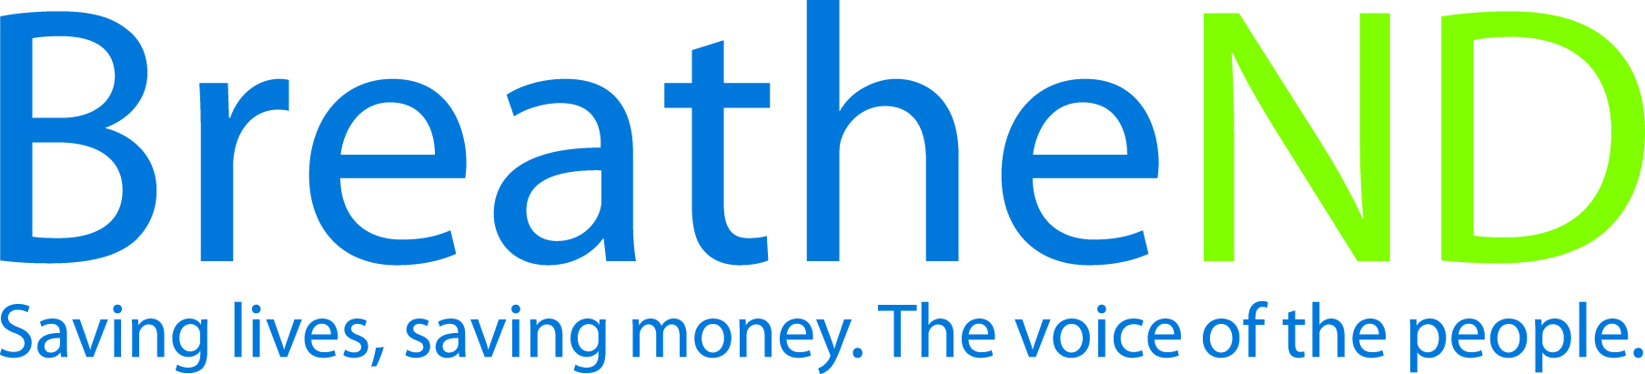  Maintain funding to local public health units, tribes, statewide and community partnerships and evaluate funding allocations dependent on emerging issues.
Activities |  | Key achievements and challenges
Funding the LPHUs, tribes, statewide and community partners is level or increased  Emerging issues identified  Funding increased to target areas |  | Q1:
 |  | Q2:
 |  | Q3:
 |  | Q4:
Strategy #2 | Assure staff is adequate in number, have qualifications, and competency in tobacco prevention and control.
Activities |  | Key achievements and challenges
Grant staffing requirements met  Quarterly training attended  Participation rate in monthly local policy calls  Number of contacts with supervisors |  | Q1:
 |  | Q2:
 |  | Q3:
 |  | Q4:
Strategy #3 | Update strategic annual training plan for grantees, partners, tribal partners, and Advisory Committee.
Activities |  | Key achievements and challenges
Health equity principles are integrated into training plan  Training plan reviewed  Training plan updated |  | Q1:
 |  | Q2:
 |  | Q3:
 |  | Q4:
Strategy #4 | Provide quarterly strategic trainings interfaced with the state plan and work plan objectives and technical assistance to grantees and partners.
Activities |  | Key achievements and challenges
Trainings scheduled  Save the dates sent out  Trainings complete and evaluations analyzed |  | Q1:
 |  | Q2:
 |  | Q3:
 |  | Q4:
Strategy #5 | Build, practice and strengthen skills in mobilizing partners and effectively communicating with decision makers about policy change at grassroots to support and reinforce “Saving Lives, Saving Money” in communities i.e. public, boards of health, policy and decision makers and to effectively counter pro-tobacco influences.
Activities |  | Key achievements and challenges
Number of new coalitions  Increased coalition members documented |  | Q1:
 |  | Q2:
 |  | Q3:
 |  | Q4:
Strategy #6 | Monitor grantee and contractor work plan and budget activities.
Activities |  | Key achievements and challenges
Quarterly review  Revisions as needed, requested, and obtained |  | Q1:
 |  | Q2:
 |  | Q3:
 |  | Q4:
Strategy #7 | Collaborate with local states attorneys, and law enforcement to ensure compliance with local and state smoke-free laws.
Activities |  | Key achievements and challenges
Noted level of activity in quarterly reports |  | Q1:
 |  | Q2:
 |  | Q3:
 |  | Q4:
Strategy #8 | Publicize tobacco prevention and control successes.
Activities |  | Key achievements and challenges
Earned media documented  Paid media documented  Social and digital media documented  Public celebrations documented |  | Q1:
 |  | Q2:
 |  | Q3:
 |  | Q4:

