ND Center for Tobacco Prevention and Control Policy State Workplan Report 2016-2018
Organization Date Completed
Initiative | Administrative Structure | Primary Goal | #4 Build Capacity
Objective #1 | By June 30, 2017, maintain and enhance the administrative structure to manage the comprehensive North Dakota Tobacco Prevention and Control Program adjusted annually by most current CDC Best Practice for Tobacco Prevention and Control Programs.
Strategy #1 | 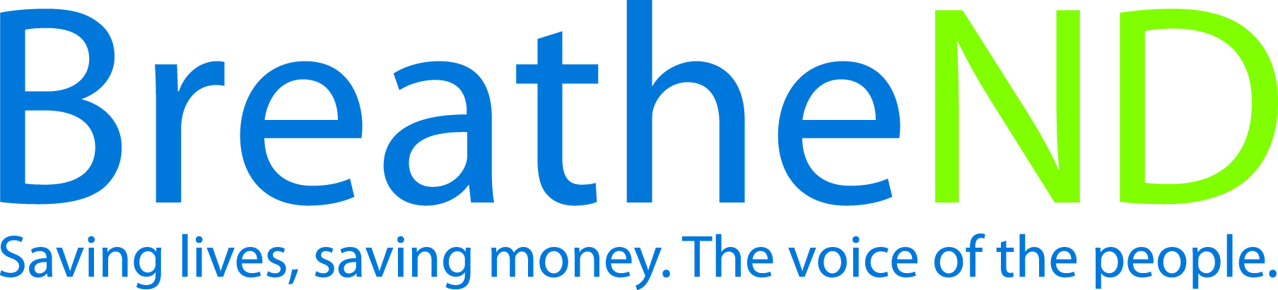  Align initial budget, then maintain and document biennial fiscal management and program budgets by most current CDC Best Practice recommended percentages.
Activities |  | Key achievements and challenges
Expenditures on track quarterly  Corrections made |  | Q1:
 |  | Q2:
 |  | Q3:
 |  | Q4:
Strategy #2 | Maintain and enhance a fiscal and programs management/reporting system to ensure program accountability at the state and local level and for state grantees or contractors.
Activities |  | Key achievements and challenges
Conduct biennial review of reporting systems  Identify reporting system gaps, issues, and improvement areas  Develop and implement reporting system enhancements  Continue monitoring reporting system |  | Q1:
 |  | Q2:
 |  | Q3:
 |  | Q4:
Strategy #3 | Advocate for most current CDC Best Practice state level funding.
Activities |  | Key achievements and challenges
Assess legislative support  Legislative meetings held  Testimony given  Final vote on budget recorded |  | Q1:
 |  | Q2:
 |  | Q3:
 |  | Q4:
Strategy #4 | Recruit and employ competent and adequate number of staff to achieve program goals.
Activities |  | Key achievements and challenges
Staffing levels evaluated with program goal achievement  Job descriptions written  Legislative approval received  Recruitment plan for new FTE completed  Maintain adequate staffing  Retain staffing |  | Q1:
 |  | Q2:
 |  | Q3:
 |  | Q4:
Strategy #5 | Review and modify annual grant allocation guidelines.
Activities |  | Key achievements and challenges
Guidelines reviewed  Guidelines modified |  | Q1:
 |  | Q2:
 |  | Q3:
 |  | Q4:
Strategy #6 | Integrate goals, objectives, and strategies from the State Tobacco Prevention and Control Plan, “Saving Lives, Saving Money” into ND Department of Health Chronic Disease CDC tobacco prevention grant, state wide coalitions, state wide and allied health organizations and associations.
Activities |  | Key achievements and challenges
Document resolutions signed  Document entities integrating |  | Q1:
 |  | Q2:
 |  | Q3:
 |  | Q4:
Strategy #7 | Implement the Health Communications Plan, educating the public and decision makers on the health effects of tobacco use and evidence-based program and policy interventions.
Activities |  | Key achievements and challenges
Earned print media documented and analyzed  Social media documented and analyzed |  | Q1:
 |  | Q2:
 |  | Q3:
 |  | Q4:
Strategy #8 | Participate in professional development opportunities.
Activities |  | Key achievements and challenges
Staff professional development activities documented |  | Q1:
 |  | Q2:
 |  | Q3:
 |  | Q4:
Strategy #9 | Assist in recruiting and provide orientation to new advisory committee members.
Activities |  | Key achievements and challenges
Identify potential advisory committee members according to NDCC 23-42-02  Provide the potential advisory committee members to the governor’s office and/or the respective organizations  Orientation documented and filed |  | Q1:
 |  | Q2:
 |  | Q3:
 |  | Q4:

