ND Center for Tobacco Prevention and Control Policy State Workplan Report 2016-2018
Organization Date Completed
Initiative | Mental Health | Primary Goal | #3 Promote Quitting
Objective #3 | By June 30, 2017, ensure that providers in behavioral treatment programs provide clients with evidence-based nicotine dependence interventions.
Strategy #1 | 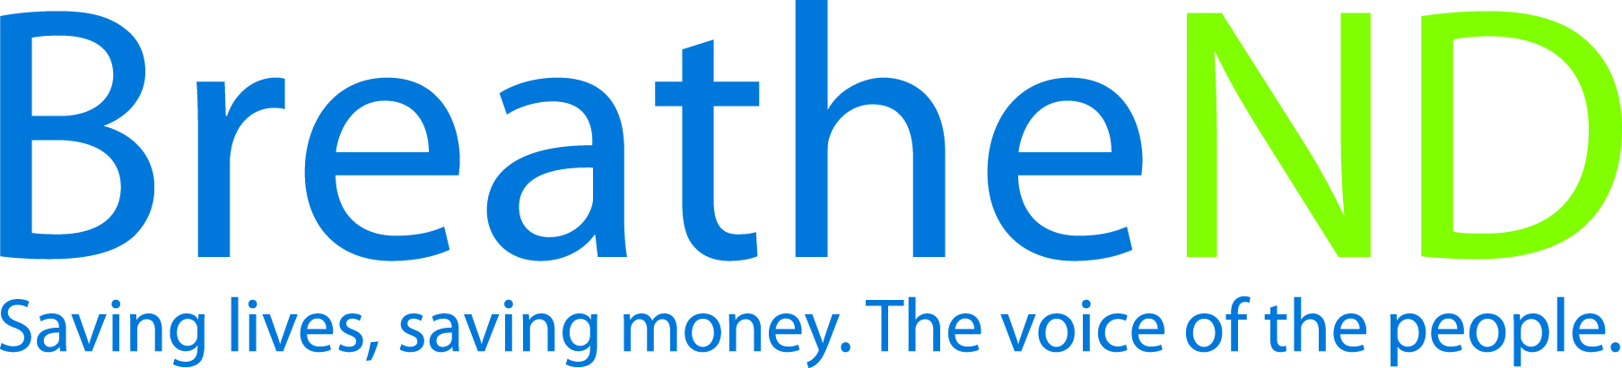  Assess current interventions used during the treatment period and develop a database.
Activities |  | Key achievements and Challenges
Assessment completed  Database completed |  | Q1:
 |  | Q2:
 |  | Q3:
 |  | Q4:
Strategy #2 | Provide and document educational opportunities for licensed mental health practitioners, addiction counselors, and students about treating tobacco use during the treatment process.
Activities |  | Key achievements and Challenges
Educational opportunity developed and implemented—date  Attendance documented  Feedback evaluated |  | Q1:
 |  | Q2:
 |  | Q3:
 |  | Q4:
Strategy #3 | Work with providers to integrate clients quitting, offer addiction counseling related to nicotine/tobacco dependence and provide recommended FDA approved tobacco cessation therapies into standards of practice during behavioral health treatment.
Activities |  | Key achievements and Challenges
Meeting set up  Meeting completed  Number of private providers implementing more than previously documented |  | Q1:
 |  | Q2:
 |  | Q3:
 |  | Q4:
Strategy #4 | Promote tobacco-free campuses for all half-way houses, transitional living, homeless shelters, human service centers, and addiction treatment facilities.
Activities |  | Key achievements and Challenges
Research on venues completed  List developed  Contacts made and meetings scheduled  Meetings completed  Number of venues with tobacco-free campuses |  | Q1:
 |  | Q2:
 |  | Q3:
 |  | Q4:

