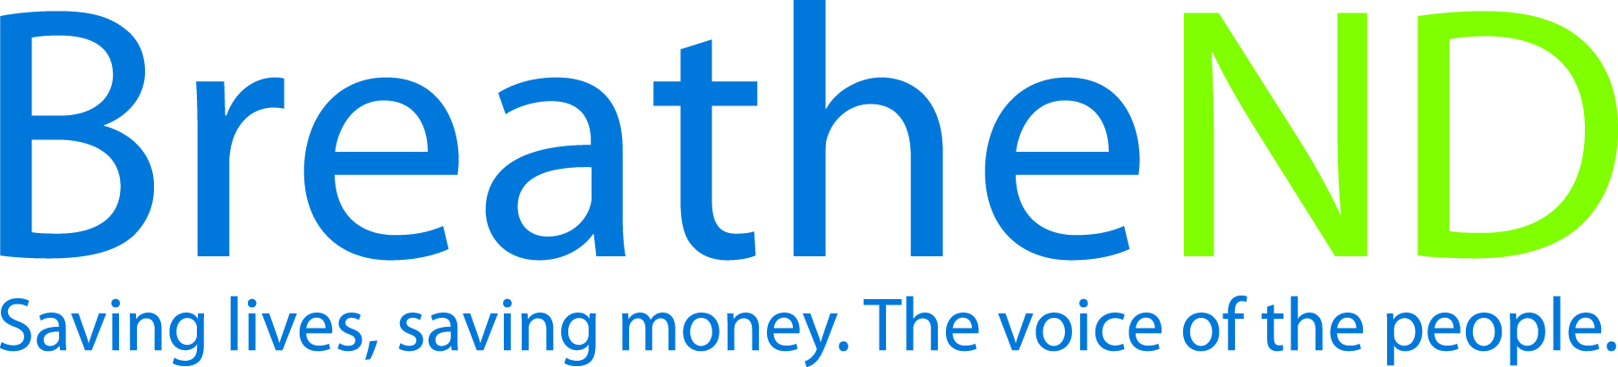
ND Center for Tobacco Prevention and Control Policy State Workplan Report 2016-2018
Organization Date Completed
Initiative | Public Health Service Guidelines | Primary Goal | #3 Promote Quitting
Objective #2 | By June 30, 2018, increase the number of health care settings and enhance public health agencies use of the systems approach for tobacco dependence treatment as recommended in the US Public Health Service Treating Tobacco Use and Dependence, Clinical Practice Guideline—2008 Update.
Strategy #1 | Provide education and technical assistance to health care providers on implementation to deliver 5As of the Public Health Service Guidelines for Treating Tobacco Use and Dependence i.e. Clarify and strengthen skills to motivate clients, describe medication options, offer immediate on site counseling and offer/direct medication options and document exposure to secondhand smoke, i.e. Ask about tobacco use, Advise to quit, Assess willingness to make a quit attempt, Assist in aiding the patient in quitting by providing counseling (refer to cessation services for additional support) and medications and Arrange-ensure follow-up contact.
Activities |  | Key achievements and challenges
Identify, health care systems approach  Education and training offered—date  Systematic implementation in delivery of health care  Develop protocols to provide cessation intervention to parents of hospitalized children focusing work with health care systems |  | Q1:
 |  | Q2:
 |  | Q3:
 |  | Q4:
Strategy #2 | Implement and expand the Million Heart S grant for eligible health care systems.
Activities |  | Key achievements and challenges
Attendance in scheduled conference calls  Outcomes reported annually by site  Number of new grantees per grant cycle  Implementation of direct e-referral  Strategic focus to ‘expand’ components (e-referral, cessation centers, NRT protocols, data collection and 7 month follow-up) |  | Q1:
 |  | Q2:
 |  | Q3:
 |  | Q4:
Strategy #3 | Advocate for health care providers to implement provider reminder systems; especially focusing on populations affected by tobacco-related disparities.
Activities |  | Key achievements and challenges
Feedback received  Implementation of reminder systems  Identified populations affected by tobacco related disparities in targeted areas |  | Q1:
 |  | Q2:
 |  | Q3:
 |  | Q4:
Strategy #4 | Conduct annual program or population based audit of AAR/SHS exposure in local public health units.
Activities |  | Key achievements and challenges
Completed by requested date  Results shared with local public health units and partners |  | Q1:
 |  | Q2:
 |  | Q3:
 |  | Q4:
Strategy #5 | Advocate for annual reports/audits of 5As in health care systems that have implemented Public Health Service Guidelines for Treating Tobacco Use and Dependence for internal quality improvement.
Activities |  | Key achievements and challenges
Number of reports/audits completed  Analysis of results  Evaluation compared to Adult Tobacco Survey |  | Q1:
 |  | Q2:
 |  | Q3:
 |  | Q4:
Strategy #6 | Partner with the ND Department of Human Services and 8 regional human services centers as priority organization.
Activities |  | Key achievements and challenges
Assess current tobacco interventions practices  Implementation plan of 5As developed  Implementation 5As in treatment plans completed  Evaluation of plan and adjustments |  | Q1:
 |  | Q2:
 |  | Q3:
 |  | Q4:
Strategy #7 | Advocate that all healthcare settings and local public health units have a systematic orientation process for implementation of Public Health Service Guidelines for Treating Tobacco Use and Dependence for all employees with direct client care responsibilities.
Activities |  | Key achievements and challenges
Contact appropriate health care administrators  Local public health complete as grant requirements |  | Q1:
 |  | Q2:
 |  | Q3:
 |  | Q4:

