ND Center for Tobacco Prevention and Control Policy State Workplan Report 2016-2018
Organization Date Completed
Initiative | NDQuits | Primary Goal | #3 Promote Quitting
Objective #1 | By June 30, 2018, increase annual treatment reach of NDQuits to 2.5% of all smokers and smokeless tobacco users.
Strategy #1 | 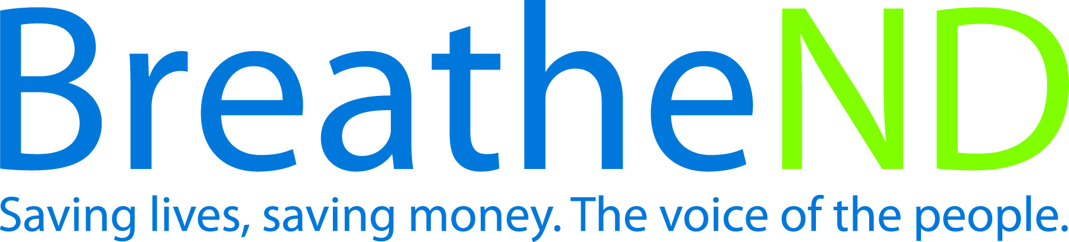  Target regions and priority populations where evaluation has indicated need for paid and earned media campaigns.
Activities |  | Key achievements and challenges
Media/outreach plan developed  Media/outreach plan implemented  Evaluation analyzed  Changes/additions to media/outreach plan complete  Paid and earned media documented with dates |  | Q1:
 |  | Q2:
 |  | Q3:
 |  | Q4:
Strategy #2 | Promote cessation services with the Campus Tobacco Prevention Project.
Activities |  | Key achievements and challenges
Promotional materials distribution tracked  Analyze NDQuits enrollment data for 18-24 years old  Assess the percentage of first-year students who complete the online health assessment with personalized feedback  Assess number of students utilizing tobacco education unit  Adjust project as evaluation indicates to increase reach |  | Q1:
 |  | Q2:
 |  | Q3:
 |  | Q4:
Strategy #3 | Expand NDQuits services to include emerging technologies.
Activities |  | Key achievements and challenges
Technologies researched  Technology improvements made  Analysis of usage of new technologies |  | Q1:
 |  | Q2:
 |  | Q3:
 |  | Q4:
Strategy #4 | Provide education about NDQuits to providers in healthcare settings, health insurance providers, priority populations, worksites, and community services and resources, as well as supporting community tobacco prevention control efforts by using motivational interviewing, problem solving, and marketing of services.
Activities |  | Key achievements and challenges
Training offered on NDQuits  Adapt outreach/education plan from CDC  Implement outreach/education plan with focus on e-referrals  Analysis of healthcare referral numbers  Implement changes as analysis determines |  | Q1:
 |  | Q2:
 |  | Q3:
 |  | Q4:
Strategy #5 | Provide NRT for eligible, enrolled uninsured and underinsured tobacco users for up to 8 weeks through NDQuits and some local public health units.
Activities |  | Key achievements and challenges
Amount supplied  Eligibility criteria determined and modified  Implement utilization of combination NRT with NDQuits clients  Develop and implement tracking for use of combination NRT |  | Q1:
 |  | Q2:
 |  | Q3:
 |  | Q4:
Strategy #6 | Distribute quarterly NDQuits reports to partners.
Activities |  | Key achievements and challenges
County-level reports sent to the local public health unit  State-level reports sent to ND Center, American Lung Association of ND and other partners |  | Q1:
 |  | Q2:
 |  | Q3:
 |  | Q4:
Strategy #7 | Complete and distribute annual evaluation to partners.
Activities |  | Key achievements and challenges
Annual evaluation plan developed  Evaluation and analysis completed by external evaluator  Distribution completed |  | Q1:
 |  | Q2:
 |  | Q3:
 |  | Q4:
Strategy #8 | Assure Medicaid coverage of over-the-counter and prescription pharmacotherapy for tobacco use cessation.
Milestones |  | Key achievements and challenges
Discussions with Medicaid related to identified barriers  Discussion and implementation to identify tobacco users receiving Medicaid  Coverage continues  Develop interactive web based cessation intervention counseling for allied health care providers  Implement interactive web-based cessation intervention training for allied health care providers by January 2017  Discussion with Medicaid related to NDQuits enrollment in Federal Financial Partnership (FFP) |  | Q1:
 |  | Q2:
 |  | Q3:
 |  | Q4:

