ND Center for Tobacco Prevention and Control Policy State Workplan Report 2016-2018
Organization Date Completed
Initiative | Preemption | Primary Goal | #2 Eliminate Secondhand Smoke Exposure
Objective #2 | By June 30, 2017, prevent preemption in all North Dakota state tobacco prevention and control laws.
Strategy #1 | 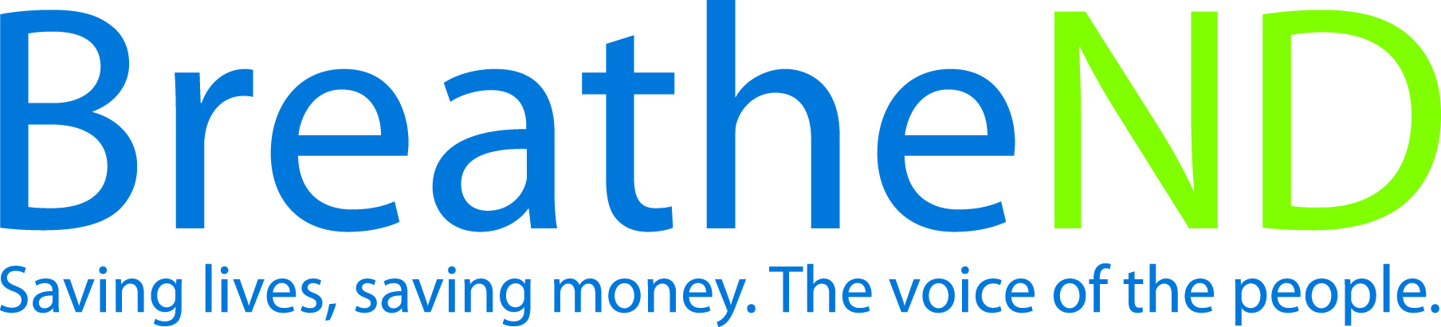  Educate the public, grantees, partners, and policy makers.
Activities |  | Key achievements and challenges
Earned media documented  Legislators contacted and received educational materials  Number of educational presentations and to whom |  | Q1:
 |  | Q2:
 |  | Q3:
 |  | Q4:
Strategy #2 | Monitor legislative bills.
Activities |  | Key achievements and challenges
Bill proposals reported |  | Q1:
 |  | Q2:
 |  | Q3:
 |  | Q4:
Strategy #3 | Maintain and expand data base of anti-preemption Board of Health Resolutions.
Activities |  | Key achievements and challenges
Completed |  | Q1:
 |  | Q2:
 |  | Q3:
 |  | Q4:
Strategy #4 | Encourage local communities to pass more stringent tobacco prevention ordinances.
Activities |  | Key achievements and challenges
Presentations to local communities  Number of local cities/counties adopting more stringent ordinances |  | Q1:
 |  | Q2:
 |  | Q3:
 |  | Q4:

