ND Center for Tobacco Prevention and Control Policy State Workplan Report 2016-2018
Organization Date Completed
Initiative | Smoke-Free Law | Primary Goal | #2 Eliminate Secondhand Smoke Exposure
Objective #1 | By June 30, 2017, uphold the North Dakota Smoke-Free Law as passed in November, 2012.
Strategy #1 | 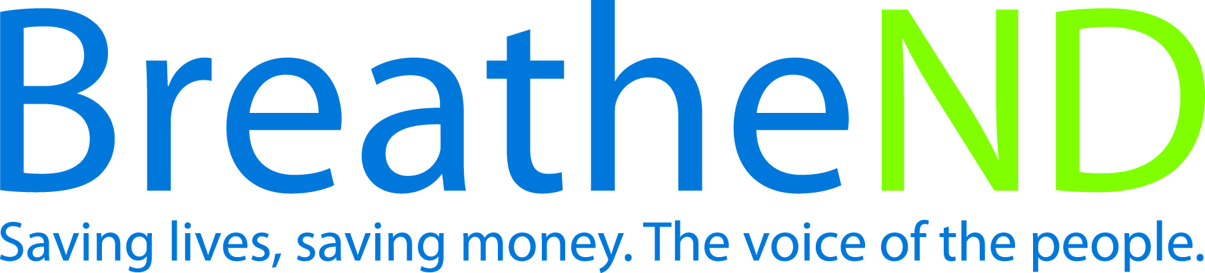  Educate the public, partners, and policy makers on smoke-free environment issues, including compliance and implementation of smoke-free law.
Activities |  | Key achievements and challenges
Educated the public, partners, and policy makers on smoke-free environment issues  Earned media documented  Policy makers contacts documented—dates |  | Q1:
 |  | Q2:
 |  | Q3:
 |  | Q4:
Strategy #2 | Educate on the benefits of and encourage local cities to adopt state law or comprehensive smoke-free model law into city code.
Activities |  | Key achievements and challenges
Presentations to cities completed  Number of local cities adopting state law or model law |  | Q1:
 |  | Q2:
 |  | Q3:
 |  | Q4:
Strategy #3 | Monitor legislative activity and intervene as necessary to deflect efforts to weaken current law.
Activities |  | Key achievements and challenges
Potential legislative interim/regular committees identified  Interim/regular committees attended—dates  Key legislators identified—names  Key legislative council staff contacted  Interventions completed—dates |  | Q1:
 |  | Q2:
 |  | Q3:
 |  | Q4:
Strategy #4 | Identify, monitor, and combat tobacco industry influence.
Activities |  | Key achievements and challenges
Tactics identified as advertising and marketing of current and emerging products, legislative, C-store buy-in  Responses prepared and issued  Response evaluated |  | Q1:
 |  | Q2:
 |  | Q3:
 |  | Q4:
Strategy #5 | Conduct public poll, communicate and distribute results of ongoing support for smoke-free law.
Activities |  | Key achievements and challenges
Survey instrument written and approved  Survey conducted  Results analyzed  Plan developed  Health Communication/distribution plan developed  Health Communication plan implemented |  | Q1:
 |  | Q2:
 |  | Q3:
 |  | Q4:
Strategy #6 | Conduct valid and reliable survey of legislators and candidates on smoke-free issues.
Activities |  | Key achievements and challenges
Survey instrument written and approved  Survey conducted  Results analyzed  Plan developed |  | Q1:
 |  | Q2:
 |  | Q3:
 |  | Q4:
Strategy #7 | Review and update annually evidence base, fact sheets, and policy documents.
Activities |  | Key achievements and challenges
June 30, 2015 documents updated  June 30, 2016 documents updated  June 30, 2017 documents updated |  | Q1:
 |  | Q2:
 |  | Q3:
 |  | Q4:
Strategy #8 | Engage tribal leaders in discussion about adoption of comprehensive smoke-free law.
Activities |  | Key achievements and challenges
Meetings held with Indian Affairs and NDDOH  Plan developed  Meetings held with tribal leaders  Number of tribal leaders committed |  | Q1:
 |  | Q2:
 |  | Q3:
 |  | Q4:
Strategy #9 | Provide technical assistance for compliance and implementation of law.
Activities |  | Key achievements and challenges
Staff notes from local policy call  Staff monthly reports to supervisor |  | Q1:
 |  | Q2:
 |  | Q3:
 |  | Q4:
Strategy #10 | Enlist environmental health staff at state and local levels to enhance and maintain compliance of law.
Activities |  | Key achievements and challenges
Contact list obtained  Materials developed  Contacts completed—dates  Commitments documented |  | Q1:
 |  | Q2:
 |  | Q3:
 |  | Q4:

