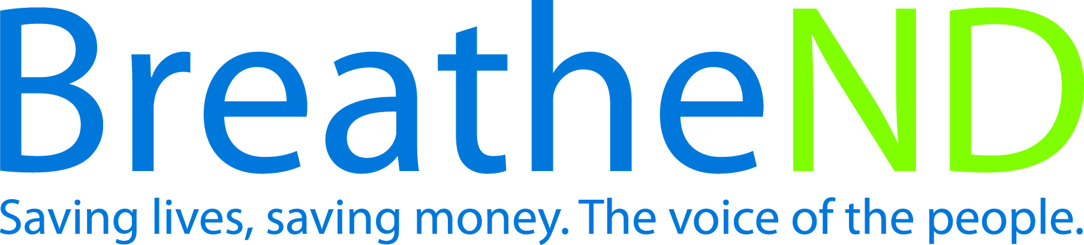
ND Center for Tobacco Prevention and Control Policy State Workplan Report 2016-2018
Organization Date Completed
Initiative | Point-of-Sale | Primary Goal | #1 Prevent Initiation
Objective #4 | By June 30, 2018, each local public health unit will adopt at least one ordinance restricting youth access to tobacco products at point of sale. develop and advocate for ordinances that restrict youth access to all tobacco products at point-of-sale.
Strategy #1 | Provide education for grantees, coalitions, local and state policy makers, local communities, youth, and leaders on tobacco industry strategies that recruit new users and increase use i.e.,  - Tobacco advertising and marketing tactics: price discounts, in-store branded displays, payment for prime shelf space, packaging design  - Oppose a tobacco price increase  - Location of tobacco retailers
Activities |  | Key achievements and challenges
Materials developed  Trainings held  Policy makers contacted and received educational materials |  | Q1:
 |  | Q2:
 |  | Q3:
 |  | Q4:
Strategy #2 | Conduct statewide and local retail environment study of tobacco marketing.
Activities |  | Key achievements and challenges
Study designed  Study conducted  Report written and distributed  Next steps developed |  | Q1:
 |  | Q2:
 |  | Q3:
 |  | Q4:
Strategy #3 | Grantees mobilize grassroots to garner support for stronger local policies.
Activities |  | Key achievements and challenges
Develop strategies  Community organizations activated  Letters to editor by geographic area on file  Earned media documented and on file  Other campaigns, if done, documented and on file |  | Q1:
 |  | Q2:
 |  | Q3:
 |  | Q4:
Strategy #4 | Educate local coalitions and communities about local/state ordinance options to prevent youth tobacco use initiation incorporating Counter Tools local assessment data.  - Restrict the number, type, and location of tobacco retailers by retail licensing, zoning law, or direct regulation of who can sell tobacco products  - Restrict the placement of tobacco products in retail store behind the counter  - Pricing restrictions by regulation of price promotions, or limit or prohibit price discounting mechanisms like coupons, multipack discounts, and cross-promotions  - Restrict marketing tactics of payment for prime shelf space and in-store branded displays  - Restrict local electronic smoking devices sales to minors by defining electronic smoking devices as a tobacco product and requiring tobacco retail licensing.  - Increase minimum legal sale age of tobacco products (including electronic smoking devices to age 21.
Activities |  | Key achievements and challenges
Model ordinance prepared  Local champion(s) identified and secured  Local coalitions/organizations activated  Community meetings held  Earned media documented  Identified and recruited state legislator(s) champion(s) for statewide restriction on electronic smoking devices as a tobacco product, i.e. behind the counter and requiring a tobacco retail licensing  Education on age 21 as research continues  Initiate dialogue with identified policy makers as potential legislative item for minimum legal sale age of tobacco to 21. |  | Q1:
 |  | Q2:
 |  | Q3:
 |  | Q4:
Strategy #5 | Conduct level of support surveys of public as well as local and state policy and decision makers/candidates.
Activities |  | Key achievements and challenges
Public Survey:  Survey instrument written  Survey conducted  Results analyzed  Report written  Communication/distribution plan written and approved  All steps of communication plan completed  Policy maker/Candidate Survey:  Survey instrument written  Survey conducted  Results analyzed  Follow up strategy developed |  | Q1:
 |  | Q2:
 |  | Q3:
 |  | Q4:
Strategy #6 | Monitor policy attempts in local communities and state policy activity.
Activities |  | Key achievements and challenges
Policy attempts documented and analyzed  Results discussed and follow-up action determined |  | Q1:
 |  | Q2:
 |  | Q3:
 |  | Q4:
Strategy #7 | Identify, monitor, and combat tobacco industry influence.
Activities |  | Key achievements and challenges
Tactics identified as advertising and marketing of current and emerging products, legislative activities, C-store, buy-in  Responses prepared and issued/implemented  Responses evaluated |  | Q1:
 |  | Q2:
 |  | Q3:
 |  | Q4:
Strategy #8 | Provide technical assistance on FDA 2009 Family Smoking Prevention and Tobacco Control Act.
Activities |  | Key achievements and challenges
Training held at quarterly trainings and local policy calls  Staff reports filed |  | Q1:
 |  | Q2:
 |  | Q3:
 |  | Q4:
Strategy #9 | Promote adoption of Board of Health resolutions.
Activities |  | Key achievements and challenges
Number of resolutions adopted  Database started and progress reported |  | Q1:
 |  | Q2:
 |  | Q3:
 |  | Q4:

