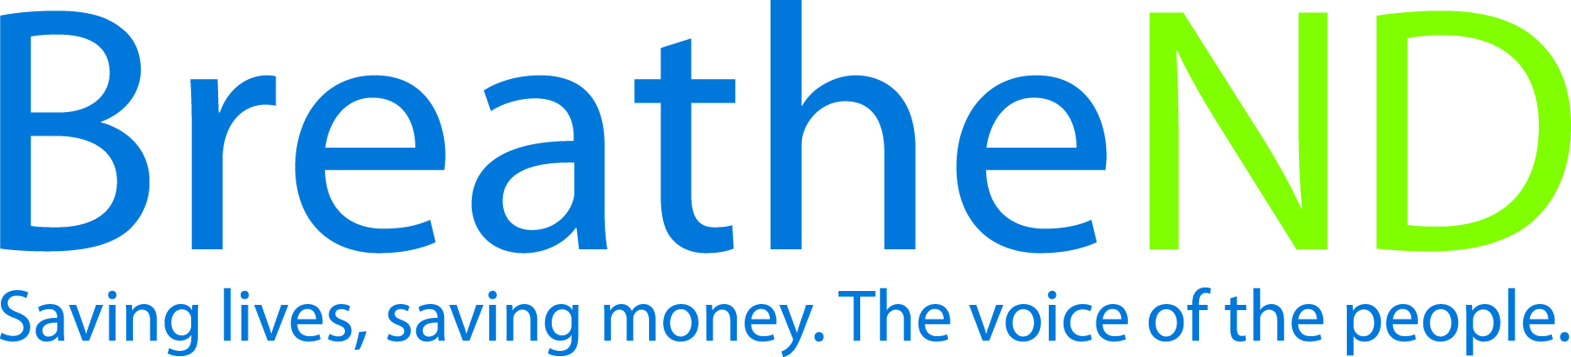
North Dakota Center for Tobacco Prevention
and Control Policy State Work Plan 2016–2018

Initiative: Sustainability Organization
Date Completed
Goal 4: Build Capacity
Goal 1: Prevent Initiation
Goal 2: Eliminate Secondhand Smoke Exposure
Goal 3: Promote Quitting
Objective 5: By June 30, 2018, sustain ND comprehensive tobacco prevention and control program in conformance with current CDC recommendations.

Rationale: “Evidence-based, statewide tobacco control programs that are comprehensive, sustained and accountable have been shown to reduce smoking rates, tobacco related deaths and diseases caused by smoking” (Best Practices for Comprehensive Tobacco Control Programs, (January 2014, p. 6).

Baseline: 2013-2015 Independent Biennial Report by RTI states the ND comprehensive tobacco prevention and control program is in conformance with the current CDC Best Practices for Tobacco Prevention programs.
Evaluation: ND Comprehensive tobacco prevention and control program based on current CDC Best Practices for Tobacco Prevention meets current CDC Best Practices for Tobacco Prevention programs for 2015-2017.

Lead: ND Center for Tobacco Prevention and Control Policy

Strategies:
☐ 1. Modify the comprehensive evidence-based tobacco prevention and control program’s state plan based on the independent biennial evaluation recommendations.
- Review and discuss recommendation with independent evaluator.
- Develop objectives, strategies and activities to address the recommendations
- Incorporate changes into the state plan
☐ 2. Advocate and communicate regularly with Governor, Health Officer, legislative body, and partners regarding progress and outcomes of program.
- Contacts made
- Independent biennial evaluation report delivered to Governor and Health Officer
☐ 3. Partners and local public health reinvigorate and mobilize local grassroots coalitions and recruit new local/statewide partners.
- Increased number of coalition members
- Records of coalition meetings
☐ 4. Communicate outcomes, the need for continual funding in light of new and emerging tobacco products/issues and the consequences of not continuing a comprehensive program.
- Added to media plan
- Added to public education strategies
- Added to policy maker and leadership communications
- Added to appropriate surveys being conducted
☐ 5. Build, practice and strengthen skills in mobilizing partners and effectively communicating with decision makers about policy change at grassroots to support and reinforce “Saving Lives, Saving Money” in communities or at the state level and to effectively counter pro-tobacco influences.
- Trainings offered
- Trainings attended with practice opportunities for communication skills
- Self-evaluation reports improvement
- Surveys of public and policy makers report support
- Reports of countering pro-tobacco influences documented
☐ 6. Examine and modify the comprehensive evidence-based tobacco prevention and control program’s state plan using The Guide to Community Preventive Services.
- Review and discuss recommendations with independent evaluator
- Develop objectives, strategies and activities to address the recommendations
- Incorporate changes into the State Plan

