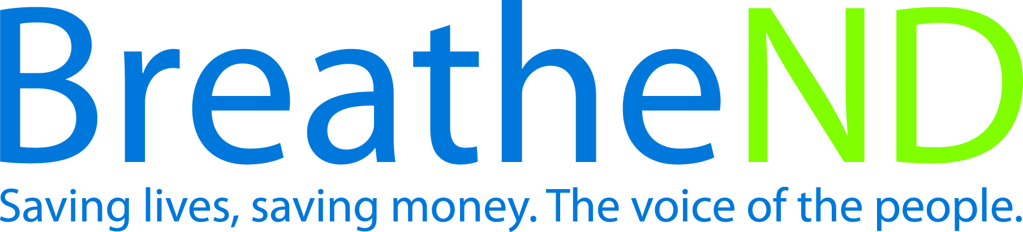
North Dakota Center for Tobacco Prevention
and Control Policy State Work Plan 2016–2018

Initiative: Surveillance and Evaluation Organization
Date Completed
Goal 4: Build Capacity
Objective 4: By June 30, 2017, review and update a comprehensive statewide surveillance and evaluation plan.

Rationale: Key outcome indicators help measure progress toward achievement of tobacco prevention and control goals and objectives.

Baseline: Since 2010 a comprehensive statewide surveillance and evaluation plan has been in place.
Evaluation: A revised, current comprehensive statewide surveillance and evaluation plan is completed.

Lead: ND Center for Tobacco Prevention and Control Policy and ND Department of Health

Strategies:
☐ 1. Meet annually with partners (government/ non-government) to assess data needs, share data sets, and distribute information.
- Meetings scheduled
- Meetings held and work assigned
- Tasks completed
☐ 2. Analyze and synthesize data or receive feedback from existing data sets, i.e. ATS, BRFSS, YRBS, YTS, National Survey on Drug Use and Health (NSDUH), ND Quits evaluation, Synar, tax, Comprehensive program independent evaluation as per ND Century Code, and other studies.
- Analysis complete
- Matrix developed
- Matrix distributed
☐ 3. Develop and implement data collection systems, research, and evaluation studies that monitor, measure, and assess program outcomes and new or emerging products.
- Needs assessed
- Studies reviewed or done
- Document where results are distributed
☐ 4. Document and publish findings from tobacco prevention control program activities and initiatives.
- Documentation complete
- Document published
☐ 5. Develop and implement tobacco prevention efforts to achieve health equity and reduce tobacco-related disparities among population groups.
- Identify population groups affected by tobacco-related disparities
- Conduct assessment of surveillance measurements of tobacco use among these population groups
- Identify tobacco use data gaps among these population groups
- Determine strategies to address data gaps among these population groups
- Implement tobacco prevention strategies in state plan
☐ 6. Maintain a current inventory of Center funded-research.
- Inventory is updated quarterly
☐ 7. Update internal evaluation and surveillance standards.
- Standards reviewed
- Revisions completed
- Updated standards distributed

