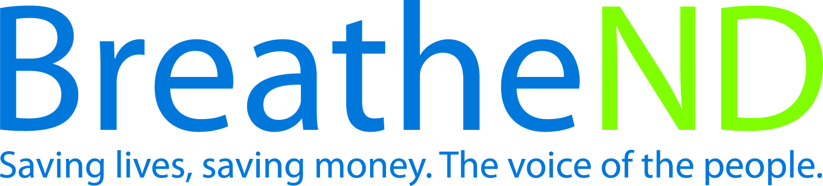
North Dakota Center for Tobacco Prevention
and Control Policy State Work Plan 2016–2018

Initiative: Health Communications Organization
Date Completed
Goal 4: Build Capacity
Goal 3: Promote Quitting
Goal 2: Eliminate Secondhand Smoke Exposure
Goal 1: Prevent Initiation
Objective 3: By June 30, 2018, implement effective, ongoing tobacco prevention and control health communication initiatives that focus on changing the broad social norms of tobacco use. The communication initiatives will deliver strategic, culturally appropriate and high-impact earned and paid messages through sustained and adequately funded campaigns integrated into the overall comprehensive North Dakota Tobacco Prevention and Control plan.

Rationale: “Mass-reach health communication interventions can be powerful tools for preventing smoking initiation, promoting and facilitating cessation, and shaping social norms related to tobacco use. (p. 30) An effective state mass reach health communication intervention delivers strategic, culturally appropriate and high-impact messages via sustained and adequately funded campaigns that are integrated into a comprehensive state tobacco control program effort. Best Practices for Comprehensive Tobacco Control Programs (January, 2014 p. 32) On December 17, 2014 the ND Center met with CDC staff and authors of Best Practice Guidelines and CDC approved the ND Center to exceed the recommended levels, due to the facts that North Dakota has a fully-funded comprehensive tobacco prevention and control program and that North Dakota youth and adult tobacco use rates are higher than the national average. It was also determined that the primary target market for transforming social norms has flexibility to target ages 25-54, with a secondary market of targeting ages 12-24.

Baseline: FY 2015 PDA health communications independent evaluation reports ND mass-reach health communication meets CDC Best Practices for Tobacco Prevention and Control Programs.

Evaluation: CDC Best Practices mass reach health communication recommended levels include: 1,600 GRPs per quarter for four quarters for addressing cessation or protecting people from the harms of secondhand smoke, targeting ages 25-54. An additional 1,200 GRPs per quarter for four quarters are recommended for each of two ongoing campaigns: transforming social norms and the remaining campaign category not included in the primary 1,600 GRP campaign.

Lead: ND Center for Tobacco Prevention and Control Policy

Strategies:
☐ 1. Maintain PETF funding from local public health units.
- LPHU funding received
☐ 2. Educate policy makers, leaders, and the public on the harmful effects of secondhand smoke and tobacco use, costs of tobacco, tobacco industry tactics, benefits of increasing the price of tobacco, cessation, increasing the minimum age of sale for all tobacco products, youth access to tobacco, point of sale strategies and new and emerging products.
- Earned media plan developed
- Earned media plan implemented
- Paid media plan developed
- Paid media plan implemented
- Surveys done/implement recommendations in media plan
- Develop and implement a millennial advocacy campaign
☐ 3. Educate policy makers, leaders, and the public, the importance of policy and its impact on changing social norms.
- Earned media plan developed
- Earned media plan implemented
- Paid media plan developed
- Paid media plan implemented
- Surveys done/ document educational efforts
- Meetings completed
☐ 4. Annually update and distribute health communications guidelines.
- Guidelines reviewed
- Research done
- Guidelines updated and approved
☐ 5. Assure that messages, where appropriate, emphasize all tobacco products.
- All messages reviewed and approved by ND Center’s Health Communications manager
☐ 6. Assure that messages, where appropriate, emphasize priority populations.
- All messages reviewed and approved by ND Center’s Health Communications manager
☐ 7. Emphasize to policy makers, leaders and the public the importance of sustaining a comprehensive tobacco prevention program funded at the CDC recommended level.
- All educational materials are reviewed by ND Center’s Health Communications manager

