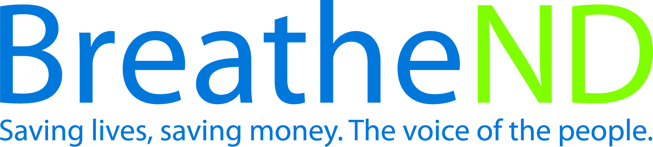
North Dakota Center for Tobacco Prevention
and Control Policy State Work Plan 2016–2018

Initiative: Local/State Capacity Organization
Date Completed
Goal 4: Build Capacity
Objective 2: By June 30, 2018, build local/state infrastructure and capacity to collaboratively deliver evidence-based tobacco prevention and control interventions from the most current CDC Best Practices for Comprehensive Tobacco Control Programs and The Guide to Community Preventive Services: Tobacco Use Prevention and Control on-going recommendations to reach all citizens in local public health units and tribal reservations including one Indian service area.

Rationale: “The social norm change model presumes that lasting change occurs through shifts in the social environment - initially or ultimately - at the grassroots level across local communities.” Best Practices for Comprehensive Tobacco Control Programs (January, 2014, p.7).

Baseline: All public health units have at least a half-time tobacco prevention coordinator position since 2012. The position due to funding may be a combination of personnel positions to equal 0.5 FTE.
Evaluation: Grantees meet or exceed 0.5 FTE tobacco prevention coordinator position.

Lead: ND Center for Tobacco Prevention and Control Policy, ND Department of Health for tribal grantees

Strategies:
☐ 1. Maintain funding to local public health units, tribes, statewide and community partnerships and evaluate funding allocations dependent on emerging issues.
- Funding the LPHUs, tribes, statewide and community partners is level or increased
- Emerging issues identified
- Funding increased to target areas
☐ 2. Assure staff is adequate in number, have qualifications, and competency in tobacco prevention and control.
- Grant staffing requirements met
- Quarterly training attended
- Participation rate in monthly local policy calls
- Number of contacts with supervisors
☐ 3. Update strategic annual training plan for grantees, partners, tribal partners, and Advisory Committee.
- Health equity principles are integrated into training plan
- Training plan reviewed
- Training plan updated
☐ 4. Provide quarterly strategic trainings interfaced with the state plan and work plan objectives and technical assistance to grantees and partners.
- Trainings scheduled
- Save the dates sent out
- Trainings complete and evaluations analyzed
- Staff notes indicate technical assistance offered
☐ 5. Build, practice and strengthen skills in mobilizing partners and effectively communicating with decision makers about policy change at grassroots to support and reinforce “Saving Lives, Saving Money” in communities i.e. public, boards of health, policy and decision makers and to effectively counter pro-tobacco influences.
- Number of new coalitions
- Increased coalition members documented
☐ 6. Monitor grantee and contractor work plan and budget activities.
- Quarterly review
- Revisions as needed, requested, and obtained
☐ 7. Collaborate with local states attorneys and law enforcement to ensure compliance with local and state smoke-free laws.
- Noted level of activity in quarterly reports
☐ 8. Publicize tobacco prevention and control successes.
- Earned media documented
- Paid media documented
- Social and digital media documented
- Public celebrations documented

