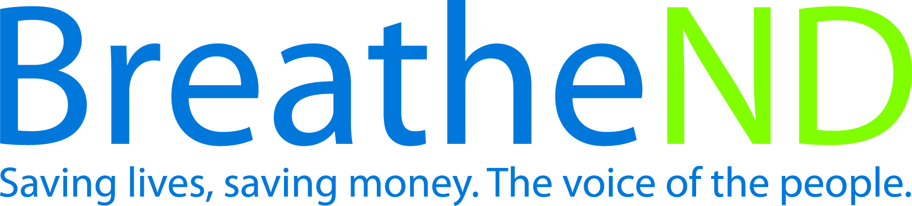
North Dakota Center for Tobacco Prevention
and Control Policy State Work Plan 2016–2018

Initiative: Administrative Structure Organization
Date Completed
Goal 4: Build Capacity
Objective 1: By June 30, 2017, maintain and enhance the administrative structure to manage the comprehensive North Dakota Tobacco Prevention and Control Program adjusted annually by most current CDC Best Practice for Tobacco Prevention and Control Programs.

Rationale: “A comprehensive tobacco control program requires considerable funding to implement; therefore a fully functioning infrastructure must be in place in order to achieve the capacity to implement effective interventions. Sufficient capacity is essential for program sustainability, efficacy and efficiency, and enables programs to plan their strategic efforts, provide strong leadership and foster collaboration among the state and local tobacco control communities. An adequate number of skilled staff is also necessary to provide or facilitate program oversight, technical assistance and training.” (Best Practices for Comprehensive Tobacco Control Programs, January, 2014, p. 64).

Baseline: January 2015 agency is fully staffed with 8 full time employees.
Evaluation: Funding based on CDC Best Practice for Tobacco Prevention and Control Programs secured for the next biennium, 2017-2019.

Lead: ND Center for Tobacco Prevention and Control Policy

Strategies:
☐ 1. Align initial budget, then maintain and document biennial fiscal management and program budgets by most current CDC Best Practice recommended percentages.
- Expenditures on track quarterly
- Corrections made
☐ 2. Maintain and enhance a fiscal and programs management/reporting system to ensure program accountability at the state and local level and for state grantees or contractors.
- Conduct biennial review of reporting system
- Identify reporting system gaps, issues, and improvement areas
- Develop and implement reporting system enhancements
- Continue monitoring reporting system
☐ 3. Advocate for most current CDC Best Practice state level funding.
- Assess legislative support
- Legislative meetings held
- Testimony given
- Final vote on budget recorded
☐ 4. Recruit and employ competent and adequate number of staff to achieve program goals.
- Staffing levels evaluated with program goal achievement
- Job descriptions written
- Legislative approval received
- Recruitment plan for new FTE completed
- Maintain adequate staffing
- Retain staffing
☐ 5. Review and modify annual grant allocation guidelines.
- Guidelines reviewed
- Guidelines modified
☐ 6. Integrate goals, objectives, and strategies from the State Tobacco Prevention and Control Plan, “Saving Lives, Saving Money” into ND Department of Health Chronic Disease CDC tobacco prevention grant, state wide coalitions, state wide and allied health organizations and associations.
- Document resolutions signed
- Document entities integrating
☐ 7. Implement the Health Communications Plan, educating the public and decision makers on the health effects of tobacco use and evidence-based program and policy interventions.
- Earned print media documented and analyzed
- Social media documented and analyzed
☐ 8. Participate in professional development opportunities.
- Staff professional development activities documented

☐ 9. Assist in recruiting and provide orientation to new advisory committee members.
- Identify potential advisory committee members according to NDCC 23-42-02
- Provide the potential advisory committee member to the governor’s office and/or the respective organizations
- Orientation documented and filed

