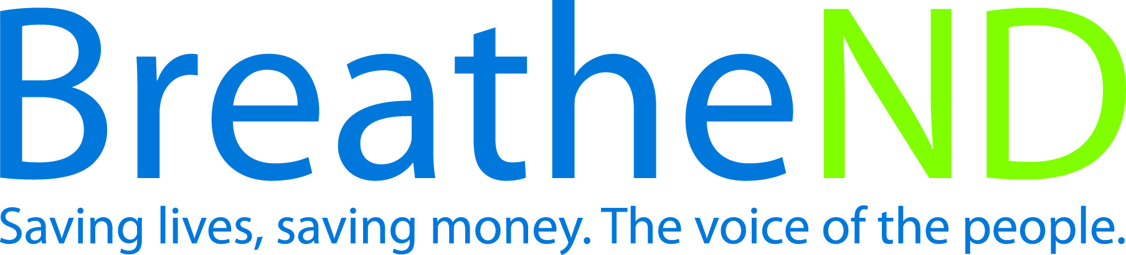
North Dakota Center for Tobacco Prevention
and Control Policy State Work Plan 2016–2018

Initiative: Mental Health Organization
Date Completed
Goal 3: Promote Quitting
Objective 3: By June 30, 2017, ensure that providers in behavioral treatment programs provide clients with evidence-based nicotine dependence interventions.

Rationale: “The National Survey on Drug Use and Health reports during 2009-2011, an annual average of 19.9% of adults aged 18 and older had mental illness defined as having a mental, behavioral or emotional disorder, excluding developmental and substance use disorders. One in 3 adults (36%) with a mental illness smoke cigarettes which is significantly higher than the national of 1 in 5 adults (21%) with no mental illness. Smoking prevalence among US adults with mental illness or serious psychological distress range from 34.3% (phobias or fears) to 88% (schizophrenia) compared to 18.3% with no such illness. In clinical settings, screening for tobacco use and offering effective cessation treatments would likely further reduce tobacco use prevalence and result in a substantial reduction in tobacco-related morbidity and mortality.” (MMWR, 2013, Vol. 62, p1-3).

Baseline: Based on an RTI survey conducted in August 2014, with a 60% response rate from 75 mental health and substance abuse treatment organizations; 50% of the respondents indicated a written policy, protocol or guideline regarding interventions to address tobacco use.
Evaluation: Increase in behavioral treatment programs written policy, protocol or guideline evidence-based nicotine dependence interventions.

Lead: ND Center for Tobacco Prevention and Control Policy Statewide Programs manager

Strategies:
☐ 1. Assess current interventions used during the treatment period and develop a database.
- Assessment completed
- Database completed
☐ 2. Provide and document educational opportunities for licensed mental health practitioners, addiction counselors, and students about treating tobacco use during the treatment process.
- Educational opportunity developed and implemented – date
- Attendance documented
- Feedback evaluated
☐ 3. Work with providers to integrate clients quitting, offer addiction counseling related to nicotine/tobacco dependence and provide recommended FDA approved tobacco cessation therapies into standards of practice during behavioral health treatment.
- Meeting set up
- Meeting completed
- Number of private providers implementing more than previously documented
☐ 4. Promote tobacco-free campuses for all half-way houses, transitional living, homeless shelters, human service centers, and addiction treatment facilities.
- Research on venues completed
- List developed
- Contacts made and meetings scheduled
- Meetings completed
- Number of venues with tobacco-free campuses

