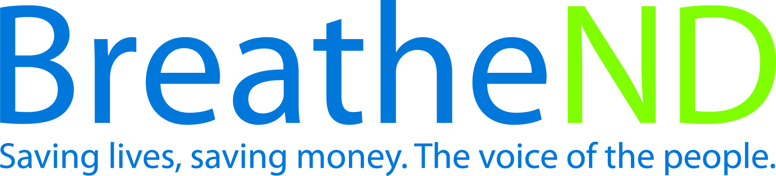
North Dakota Center for Tobacco Prevention
and Control Policy State Work Plan 2016–2018

Initiative: Public Health Service Guidelines Organization
Date Completed
Goal 3: Promote Quitting
Objective 2: By June 30, 2018, increase the number of health care settings and enhance public health agencies use of the systems approach for tobacco dependence treatment as recommended in the US Public Health Service Treating Tobacco Use and Dependence, Clinical Practice Guideline -2008 Update.

Rationale: The Community Preventive Services Task Force in The Community Guide (August, 2012) recommends “quitline interventions, particularly proactive quitlines (i.e. those that offer follow-up counseling calls), based on strong evidence of effectiveness in increasing tobacco cessation among clients interested in quitting: and policies and programs changes be communicated to health care providers and tobacco users to increase awareness, interest in quitting and use of evidence-based treatments.”

Baseline: A. Statewide local public health units meeting the established 90% standard in FY2015 (2014 calendar year chart audits) for Ask (Measure1) was 94%; Advise (Measure 2) was 85%; Refer (Measure 3) was 89% and Exposure to Secondhand Smoke (Measure 4) was 93%. B. 2012 ND Adult Tobacco Survey of ND smokers reporting health care providers Asking them about cigarette smoking was 72.2%, Advising them to quit was 48% and Referring them to cessation resources was 24.1%.
Evaluation measure: A. Statewide local public health units will meet the established 90% standard in Advise (Measure 2) and Refer (Measure 3).
B. Increased ND smokers reporting health care providers’ intervention of Ask to 80%, Advise to 60%, and Refer to 35% based on the ND Adult Tobacco Survey.

Lead: ND Department of Health and the ND Center for Tobacco Prevention and Control Policy Statewide Programs Manager

Strategies:
☐ 1. Provide education and technical assistance to health care providers on implementation to deliver 5A’s of the Public Health Service Guidelines for Treating Tobacco Use and Dependence i.e. Clarify and strengthen skills to motivate clients, describe medication options, offer immediate on site counseling and offer/direct medication options and document exposure to secondhand smoke, i.e. Ask about tobacco use, Advise to quit, Assess willingness to make a quit attempt, Assist in aiding the patient in quitting by providing counseling (refer to cessation services for additional support) and medications and Arrange-Ensure follow-up contact.
- Identify, health care systems to approach
- Education and training offered – date
- Systematic implementation in delivery of health care
- Develop protocols to provide cessation intervention to parents of hospitalized children focusing work with health care systems
☐ 2. Implement and expand the Million Heart S grant for eligible health care systems.
- Attendance in scheduled conference calls
- Outcomes reported annually by site
- Number of new grantees per grant cycle
- Implementation of direct e-referral
- Strategic focus to ‘expand’ components (e-referral, cessation centers, NRT protocols, data collection and 7 month follow-up)
☐ 3. Advocate for health care providers to implement provider reminder systems; especially focusing on populations affected by tobacco-related disparities.
- Feedback received
- Implementation of reminder systems
- Identified priority populations in targeted areas
☐ 4. Conduct annual program or population based audit of AAR/SHS exposure in local public health units.
- Completed by requested date
- Results shared with local public health units and partners
☐ 5. Advocate for annual reports/audits of 5As in health care systems that have implemented Public Health Service Guidelines for Treating Tobacco Use and Dependence for internal quality improvement.
- Number of reports/audits completed
- Analysis of results
- Evaluation compared to Adult Tobacco Survey
☐ 6. Partner with the ND Department of Human Services and 8 regional human services centers as priority organization.
- Assess current tobacco interventions practices
- Implementation plan of 5As developed
- Implementation of 5As in treatment plans completed
- Evaluation of plan and adjustments
☐ 7. Advocate that all healthcare settings and local public health units have a systematic orientation process for implementation of Public Health Service Guidelines for Treating Tobacco Use and Dependence for all employees with direct client care responsibilities.
- Contact appropriate health care administrators
- Local public health complete as grant requirements

