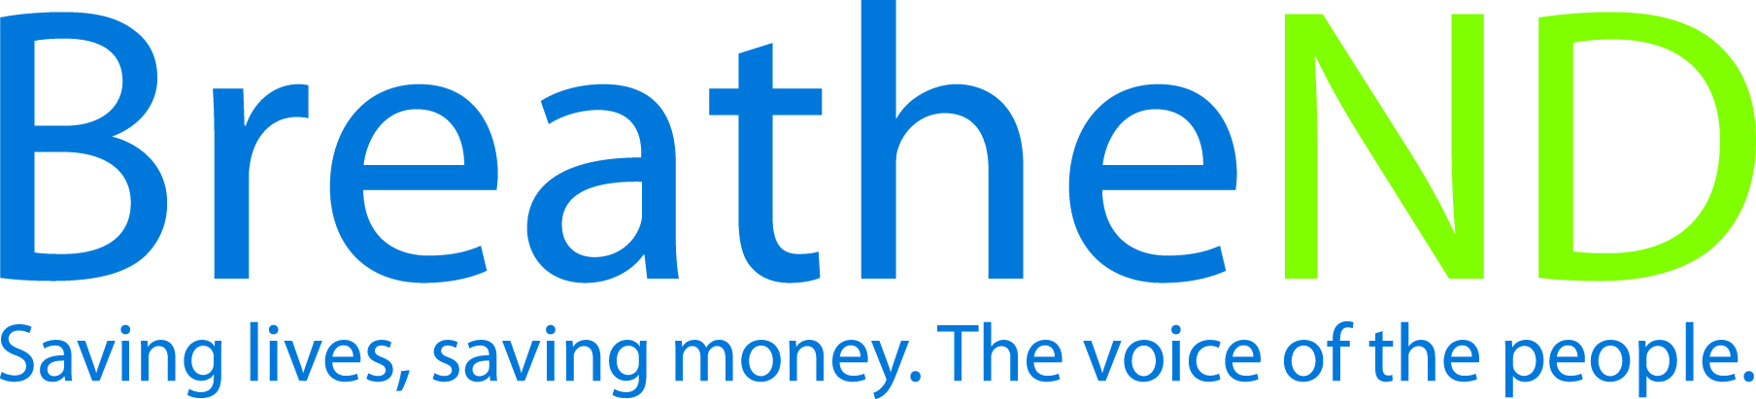

North Dakota Center for Tobacco Prevention
and Control Policy State Work Plan 2016–2018

Initiative: NDQuits Organization
Date Completed
Goal 3: Promote Quitting
Objective 1: By June 30, 2018, increase annual treatment reach of NDQuits to 2.5% of all smokers and smokeless tobacco users.

Rationale: The Community Guide from Community Preventive Services Task Force(August, 2012) recommends “three interventions effective at increasing use of quitlines; mass-reach health communications interventions that combine cessation messages with a quitline number; provision of free evidence-based tobacco cessation medications for quitline clients interested in quitting and quitline referral interventions for health care systems and providers. Evidence also indicates quitlines can help to expand the use of evidence-based services by tobacco users in populations that historically have had the most limited access to and use of evidence-based tobacco cessation treatments” (p.1). CDC baseline target rate is 6%, which no state has yet achieved.

Baseline: Annual treatment reach in FY 2015 was 1.62%

Evaluation: Increase annual treatment reach from 1.62% to 2.5%.

Lead: ND Department of Health

Strategies:
☐ 1. Target regions and priority populations where evaluation has indicated need for paid and earned media campaigns.
- Media/outreach plan developed
- Media/outreach plan implemented
- Evaluation analyzed
- Changes/additions to media/outreach plan complete
- Paid and earned media documented with dates
☐ 2. Promote cessation services with the Campus Tobacco Prevention Project.
- Promotional materials distribution tracked
- Analyze NDQuits enrollment data for 18-24 years old
- Assess the percentage of first-year students who complete the online health assessment with personalized feedback
- Assess number of student utilizing tobacco education unit
- Adjust project as evaluation indicates to increase reach
☐ 3. Expand NDQuits services to include emerging technologies.
- Technologies researched
- Technology offerings added – dates
- Analysis of usage of new technologies
☐ 4. Provide education about NDQuits to providers in healthcare settings, health insurance providers, priority populations, worksites, and community services and resources, as well as supporting community tobacco prevention control efforts by using motivational interviewing, problem solving, and marketing of services.
- Training offered on NDQuits
- Adapt outreach/education plan from CDC
- Implement outreach/education plan with focus on e-referrals
- Analysis of healthcare referral numbers
- Implement changes as analysis determines
☐ 5. Provide NRT for eligible, enrolled uninsured and underinsured tobacco users for up to 8 weeks through NDQuits and some local public health units.
- Amount supplied
- Eligibility criteria determined and modified
- Implement utilization of combination NRT with NDQuits clients
- Develop and implement tracking for use of combination NRT
☐ 6. Distribute quarterly NDQuits reports to partners.
- County-level reports sent to the local public health unit
- State-level reports sent to ND Center, American Lung Association of ND and other partners
☐ 7. Complete and distribute annual evaluation to partners.
- Annual evaluation plan developed
- Evaluation and analysis completed by external evaluator
- Distribution completed
☐ 8. Assure for Medicaid coverage of over-the-counter and prescription pharmacotherapy for tobacco use cessation.
- Discussions with Medicaid related to identified barriers
- Discussion an implementation to identify tobacco users receiving Medicaid
- Coverage continues
- Develop interactive web-based cessation intervention counseling for allied health care providers
- Implement interactive web based cessation intervention training for allied health care providers by January 2017
- Discussion with Medicaid related to NDQuits enrollment in Federal Financial Partnership (FFP)

