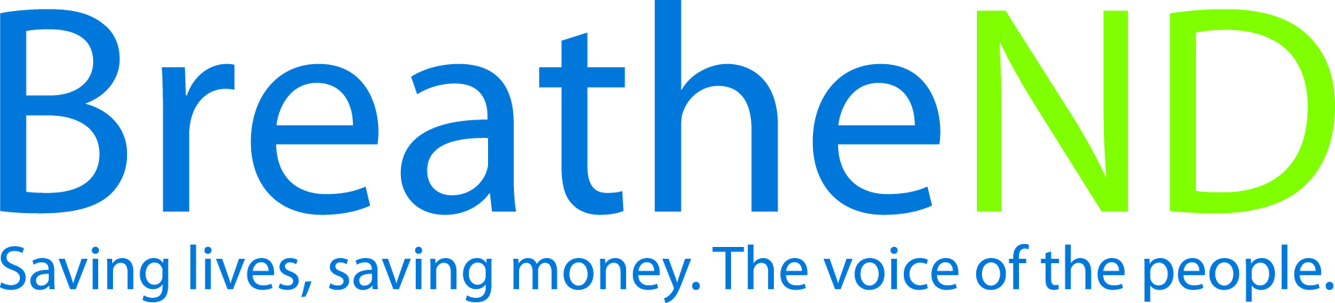
North Dakota Center for Tobacco Prevention
and Control Policy State Work Plan 2016–2018

Initiative: Indoor Air Exempted from ND Smoke-Free Law Organization
Date Completed
Goal 2: Eliminate Secondhand Smoke Exposure
Objective 3: By June 30, 2018, advocate for policies/ordinances/laws that restrict exposure to secondhand smoke and tobacco use in indoor areas not covered by ND Smoke-Free Law, e.g., multi-unit housing, casinos.

Rationale: Secondhand smoke is a well-established risk factor for morbidity and mortality due to the hundreds of toxic carcinogens found in secondhand smoke. Twenty three percent of North Dakota’s population or approximately 152,000 people reside in multi-unit housing. ND Smoke-free air law protects persons at work and in other public places. However, multi-unit housing still represents a major source of secondhand smoke exposure due to transfer of secondhand smoke through shared walls, hallways, ventilation systems, electrical lines, and plumbing systems. Exposure in multi-unit housing can be as high as 65% when air comes from other units via ventilation and smoke drift. Drifting smoke is a commonly reported complaint in multi-unit housing. Smoke-free and tobacco-free multi-unit housing benefits are decreased apartment cleaning costs, fire risks and liability, and increased marketability.

Baseline: As of quarter 2 fiscal year 2016, Public Housing Authorities in North Dakota have 491 units and 2 buildings (no units listed for these buildings) which are reported to be smoke-free. Zero (0) casinos on reservations are smoke-free.

Evaluation: Number of units where smoke-free policies have been adopted.

Lead: ND Center for Tobacco Prevention and Control Policy

Strategies:
1. Develop a multiunit housing (MUH) database.
- Define MUH to be used to evaluate efforts to increase MUH smoke-free policies
- Determine evaluation criteria for maximizing efforts to increase population protected from secondhand smoke exposure
- Use the database to establish a baseline denominator for evaluation
- Publicize available some-free housing for the public
☐ 2. Educate coalitions, policy makers, communities, state agencies, advocacy organizations and leaders on harms caused by secondhand smoke and the importance of continuing to develop policies to protect the public from secondhand smoke and tobacco use.
- Educational materials developed
- Trainings/meetings held
- Earned media documented
- Paid media planned and executed
- Contact groups and provide educational materials
- Policies adopted
- Communicate policy successes through media (website/digital/print/social)
☐ 3. Engage public, private, tribal housing and public/private licensing authorities in policy educational efforts.
- Housing list developed or obtained
- Educational materials developed or obtained
- Meetings held
- Document efforts of housing authorities
- Public licensing authorities endorse and adopt smoke-free policies
- Smoke-free policies in foster care homes are implemented
- Communicate policy successes through media (website/digital/print/social)
☐ 4. Provide education and training on proven strategies for compliance and implementation.
- Educational materials developed
- Trainings held
- http://www.breathend.com/TobaccosHarm/smokefreehousing/ website maintained
☐ 5. Provide technical assistance.
- Staff reports to supervisor
- Staff notes from local policy call
- Evaluations from webinars completed

