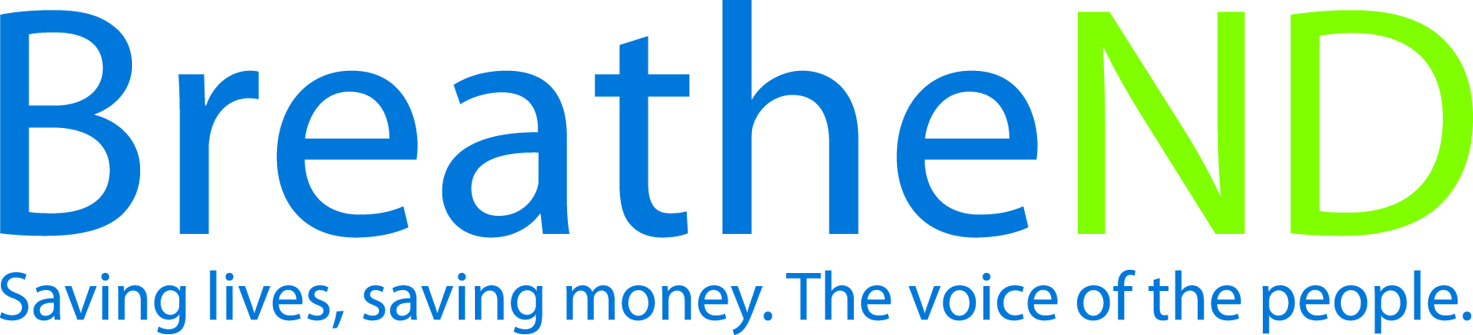
North Dakota Center for Tobacco Prevention
and Control Policy State Work Plan 2016–2018

Initiative: Preemption Organization
Date Completed
Goal 2: Eliminate Secondhand Smoke Exposure
Goal 1: Prevent Initiation
Goal 4: Build Capacity
Objective 2: By June 30, 2017, prevent preemption in all North Dakota state tobacco prevention and control laws.

Rationale: “Preemption can eliminate the benefits of state and local policy initiatives. Preemption can also have a negative impact on enforcement, civic engagement, and grassroots movement building” (Pertschuk, Pomeranz, Aoki, Larkin, Paloma, 2012) “Assessing the Impact of Federal and State Preemption in Public Health: A Framework for Decision Makers” Journal of Public Health Management Practice, June 15, 2012). Preemption is typically negotiated most times behind the scenes in Congress or state capitols between legislative sponsors or impacted industries and sometimes with representative of public health. Expect preemption to become part of any proposed public health legislation.

Baseline: As of 2013, no North Dakota state tobacco prevention and control laws have preemption measures included.

Evaluation: Absence of North Dakota state preemption and support of tobacco prevention and control laws.

Lead: ND Center for Tobacco Prevention and Control Policy

Strategies:
☐ 1. Educate the public, grantees, partners, and policy makers.
- Earned media documented
- Legislators contacted and received educational materials
- Number of educational presentations and to whom
☐ 2. Monitor legislative bills.
- Bill proposals reported
☐ 3. Maintain and expand data base of anti-preemption Board of Health Resolutions.
- Complete
☐ 4. Encourage local communities to pass more stringent tobacco prevention ordinances.
- Presentations to local communities
- Number of local cities/counties adopting more stringent ordinances

