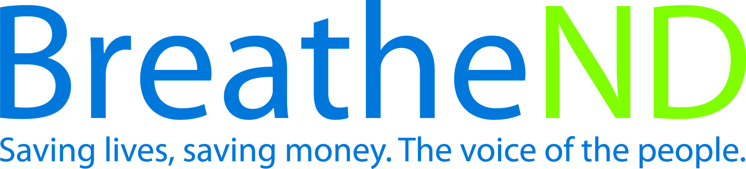

North Dakota Center for Tobacco Prevention
and Control Policy State Work Plan 2016–2018

Initiative: Smoke-Free Law Organization
Date Completed
Goal 2: Eliminate Secondhand Smoke Exposure
Goal 1: Prevent Initiation
Goal 3: Promote Quitting
Objective 1: By June 30, 2017, uphold the North Dakota Smoke-Free Law as passed in November, 2012.

Rationale: North Dakota, in November 2012, passed one of the strongest laws in the United States to protect all citizens from secondhand smoke and prevent youth initiation use of tobacco products. Secondhand smoke is a mixture of over 7,000 chemicals which contaminates both indoor and outdoor air. Exposure to secondhand smoke may lead to adverse health effects to all exposed, especially children. Some adverse health effects experienced by children are middle ear disease, respiratory symptoms, impaired lung function, asthma, pneumonia, and sudden infant death syndrome. These symptoms and diseases have been casually linked to secondhand smoke. Adults exposed to secondhand smoke, also have casually linked evidence from nasal irritation to lung cancer, coronary heart disease and reproductive effects in women, i.e. low birth weight of infants. Chronic diseases caused by smoking are clearly articulated in the US Surgeon General’s Report in How Tobacco Smoke Causes Disease, (2010, page iii), There is no safe level of exposure to cigarette smoke.

Baseline: During the 2013 North Dakota legislative session, two modifications were made to North Dakota Century Code, 23–12–09 – 23–12–11: 1) A definition of entrance was added and 2) signage necessary for compliance is available from the executive committee.

Evaluation: Any change in state smoke-free law.

Lead: ND Center for Tobacco Prevention and Control Policy

Strategies:
☐ 1. Educate the public, partners, and policy makers on smoke-free environment issues, including compliance and implementation of smoke-free law.
- Educated the public, partners and policy makers on smoke-free environment issues
- Earned media documented
- Policy makers contacts documented – dates
☐ 2. Educate on the benefits of and encourage local cities to adopt state law or comprehensive smoke-free model law into city code.
- Presentations to cities completed
- Number of local cities adopting state law or model law
☐ 3. Monitor legislative activity and intervene as necessary to deflect efforts to weaken current law.
- Potential legislative interim/regular committees identified
- Interim/regular committees attended – dates
- Key legislators identified – names
- Legislators contacted for information on possible legislation
- Key legislative council staff contacted
- Interventions completed – dates
☐ 4. Identify, monitor, and combat tobacco industry influence.
- Tactics identified as advertising and marketing of current and emerging products, legislative, C-store buy-in
- Responses prepared and issued
- Response evaluated
☐ 5. Conduct public poll, communicate and distribute results of ongoing support for smoke-free law.
- Survey instrument written and approved
- Survey conducted
- Results analyzed
- Plan developed
- Health Communication/distribution plan developed
- Health Communication plan implemented
☐ 6. Conduct valid and reliable survey of legislators and candidates on smoke-free issues.
- Survey instrument written and approved
- Survey conducted
- Results analyzed
- Plan developed
☐ 7. Review and update annually evidence base, fact sheets, and policy documents.
- June 30, 2015, documents updated
- June 30, 2016, documents updated
- June 30, 2017, documents updated
☐ 8. Engage tribal leaders in discussion about adoption of comprehensive smoke-free law.
- Meetings held with Indian Affairs and NDDOH
- Plan developed
- Meetings held with tribal leaders
- Number of tribal leaders committed
☐ 9. Provide technical assistance for compliance and implementation of law.
- Staff notes from local policy call
- Staff monthly reports to supervisor
☐ 10. Enlist environmental health staff at state and local levels to enhance and maintain compliance of law.
- Contacts made
- Contacts completed – dates
- Training using developed materials completed
- Commitments documented

