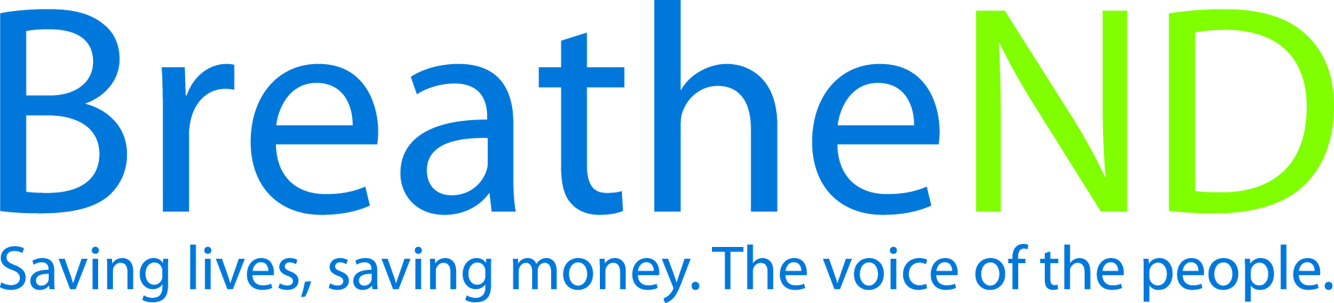
North Dakota Center for Tobacco Prevention
and Control Policy State Work Plan 2016–2018

Initiative: Point-of-Sale Organization
Date Completed
Goal 1: Prevent Initiation
Objective 4: By June 30, 2018, each local public health unit will adopt at least one ordinance restricting youth access to tobacco products at point of sale.

Rationale: In the 2012 Surgeon General’s Report on Preventing Tobacco Use Among Youth and Young Adults, “Prevention efforts must focus on both adolescents and young adults because among adults who become daily smokers, nearly all first use of cigarettes occurs by 18 years of age (88%) with 99% of first use by 26 years of age. Advertising and promotional activities by tobacco companies have been shown to cause the onset and continuation of smoking and other tobacco products use among adolescents and young adults” (p.8). The tobacco industry’s own internal correspondence and testimony in court, as well as widely accepted principles of advertising and marketing, support the conclusion that tobacco advertising recruits new users as youth and reinforces continued use among young adults. (p.522). Emerging and traditional tobacco products are the instruments for recruitment.

Baseline: Twelve* of 24 public health units have adopted at least one ordinance restricting youth access to tobacco products at point of sale. *Collaborative units in FY2016 include Trail/Steele, Ransom/Sargent, and Central Valley/Lamoure.
Evaluation: Adoption of ordinances restricting youth access to tobacco products at point of sale for remaining 12 public health units.

Lead: ND Center for Tobacco Prevention and Control Policy

Strategies:
☐ 1. Provide education for grantees, coalitions, local and state policy makers, local communities, youth, and leaders on tobacco industry strategies that recruit new users and increase use i.e.,
- Tobacco advertising and marketing tactics: price discounts, in-store branded displays, payment for prime shelf space, packaging design
- Oppose a tobacco price increase
- Location of tobacco retailers
- Materials developed
- Trainings held
- Policy makers contacted and received educational materials
☐ 2. Conduct statewide and local retail environment study of tobacco marketing.
- Study designed
- Study conducted
- Report written and distributed
- Next steps developed
☐ 3. Grantees mobilize grassroots to garner support for stronger local policies.
- Develop strategies
- Community organizations activated
- Letters to editor by geographic area on file
- Earned media documented and on file
- Other campaigns, if done, documented and on file
☐ 4. Educate local coalitions and communities about local/ state ordinance options to prevent youth tobacco use initiation incorporating Counter Tools local assessment data.
- Restrict the number, type, and location of tobacco retailers by retail licensing, zoning law, or direct regulation of who can sell tobacco products
- Restrict the placement of tobacco products in retail store behind the counter.
- Pricing restrictions by regulation of price promotions, or limit or prohibit price discounting mechanisms like coupons, multipack discounts, and cross-promotions
- Restrict marketing tactics of payment for prime shelf space and in-store branded displays.
- Restrict local electronic smoking device sales to minors by defining electronic smoking devices as a tobacco product and requiring local tobacco retail licensing.
- Increase minimum legal sale age of tobacco products (including electronic smoking devices) to age 21.
- Model ordinance prepared
- Local champion(s) identified and secured
- Local coalitions/organizations activated
- Community meetings scheduled
- Community meetings held
- Earned media documented
- Identified and recruited state legislator(s) champion(s) for statewide legislation on electronic smoking devices as a tobacco product, i.e. behind the counter and requiring a tobacco retailers license
- Education on age 21 as research continues
- Initiate dialogue with identified policy makers as potential legislative item for minimum legal sale age of tobacco to 21
☐ 5. Conduct level of support surveys of public as well as local and state policy and decision makers/candidates.
Public survey:
- Survey instrument written
- Survey conducted
- Results analyzed
- Report written
- Communication/distribution plan written and approved
- All steps of communication plan completed
Policy maker/Candidate Survey:
- Survey instrument written
- Survey conducted
- Results analyzed
- Follow up strategy developed
☐ 6. Monitor policy attempts in local communities and state policy activity.
- Policy attempts documented and analyzed
- Results discussed and follow-up action determined
☐ 7. Identify, monitor, and combat tobacco industry influence.
- Tactics identified as advertising and marketing of current and emerging products, legislative activities, C-store buy-in
- Responses prepared and issued/implemented
- Responses evaluated
☐ 8. Provide technical assistance on FDA 2009 Family Smoking Prevention and Tobacco Control Act.
- Training held at quarterly trainings and local policy calls
- Staff reports filed
☐ 9. Promote adoption of Board of Health resolutions.
- Number of resolutions adopted
- Database started and progress reported

