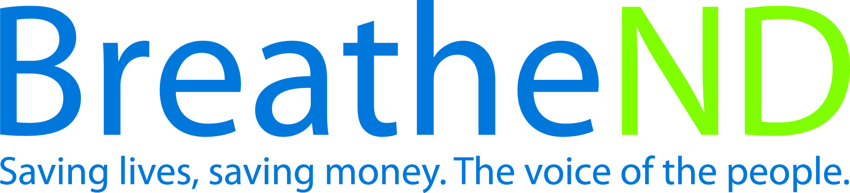
North Dakota Center for Tobacco Prevention
and Control Policy State Work Plan 2016–2018

Initiative: Post-Secondary Comprehensive Tobacco-Free Grounds Organization
Date Completed
Goal 1 : Prevent Initiation
Objective 3: By June 30, 2017, ND Center for Tobacco Prevention and Control Policy will develop with North Dakota University System (NDUS) a comprehensive post-secondary tobacco-free campus policy.

Rationale: “With 99% of all first use of tobacco occurring by age 26, if youth and young adults remain tobacco-free, very few people will begin to smoke or use smokeless products.” (2012 Surgeon General’s Report, “Preventing Tobacco Use Among Youth and Young Adults Executive Summary”). “Community programs and school and college policies and interventions should be part of a comprehensive effort, coordinated and implemented in conjunction with efforts to create tobacco-free social norms, including increasing the unit price of tobacco products, sustaining anti-tobacco media campaigns, making environments smoke-free.” (Best Practices for Comprehensive Tobacco Control Programs, January, 2014, p.19). Background information: Many of the policies currently on the tobacco-free campus policy listing were passed prior to ND Center model policy language and have missing criteria as a result.
Baseline: An endorsed tobacco free policy between the Center and NDUS has yet to be established. Currently, United Tribes Technical College is the only post-secondary institution which meets the Center’s comprehensive post-secondary tobacco-free campus policy.

Evaluation: Comprehensive post-secondary tobacco-free campus policy developed and endorsed by both the Center and NDUS.

Lead: ND Center for Tobacco Prevention and Control Policy

Strategies:
☐ 1. Collaborate with NDUS to take policy implementation action.
- Identify key NDUS personnel
- Draft policy
- Review draft policy with key NDUS personnel
- Meet with NDUS personnel
- Receive endorsement of comprehensive post-secondary tobacco-free campus policy
- Communicate progress with local public health tobacco prevention coordinators
☐ 2. Grantees complete annual assessment.
- Assessment tool completed
- Follow-up evaluation on efficacy of assessment
- Changes made to assessment tool
☐ 3. Center maintains/updates campus tobacco policy database.
- Database updated quarterly
☐ 4. Highlight comprehensive tobacco-free campus success.
- Earned media documented and on file
- Communicate policy success through media (website/digital/print/social)
5. Acknowledge traditional tobacco as deemed appropriate by institutions.
- Policy language researched, written and communicated to campuses
- Document feedback and action taken

