l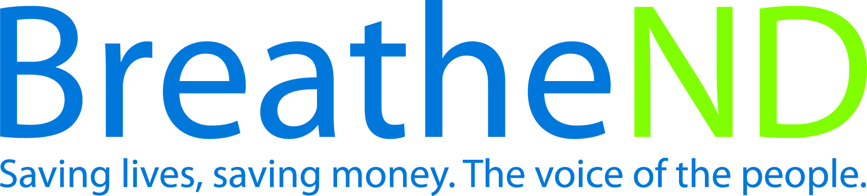

North Dakota Center for Tobacco Prevention
and Control Policy State Work Plan 2016–2018

Initiative: K-12 Schools Organization
Date Completed
Goal 1: Prevent Initiation
Objective 2: By June 30, 2018, The ND Center for Tobacco Prevention and Control Policy comprehensive model tobacco-free school policy will cover 90% of the total student enrollment and be adopted by 90% of the Local Education Agencies (LEA) in each public health unit.
Rationale: “Community programs and school and college policies and interventions should be part of a comprehensive effort, coordinated and implemented in conjunction with efforts to create tobacco-free social norms, including increasing the unit price of tobacco products, sustaining anti-tobacco media campaigns and making environments smoke-free.” (Best Practices for Comprehensive Tobacco Control Programs, January 2014, p. 19). Tobacco-free school policy promotes a tobacco-free lifestyle and environment for all students, staff and visitors and establishes a tobacco-free social norm.
Baseline: ND has 227 Local Education Agencies in FY 2016. As of December 31, 2015, 149 (66%) of the LEAs have adopted comprehensive tobacco-free school policies and 66.7% of LEA student enrollment are protected by comprehensive tobacco-free school policies.
Evaluation: 90% of total student enrollment will be covered by a comprehensive tobacco-free policy. 90% of the LEAs in each public health unit will adopt or maintain a comprehensive tobacco-free policy.
Lead: ND Center for Tobacco Prevention and Control Policy

Strategies:
☐ 1. Communicate with School Health Interagency/Community Work Group (SHIW) about the ND Center for Tobacco Prevention and Control Policy (ND Center) comprehensive model tobacco-free school policy (August 2013).
- Meetings attended with SHIW
- Input from SHIW documented and distributed to partners
☐ 2. ND Center staff/grantees secure endorsement from other potential partners (i.e., ND United, ND Council of Educational Leaders) in addition to continuing dialogue with the North Dakota School Boards Association (NDSBA) for the August 2013 ND Center for Tobacco Prevention and Control Policy comprehensive model tobacco-free school policy.
- ND Department of Health and ND Center staff meet with NDSBA for clarification and endorsement of ND Center’s comprehensive tobacco-free policy
- Endorsement from NDSBA received
- Meetings held with other key partners
- Endorsements received from key partners
☐ 3. Local public health grantees conduct and coordinate work to facilitate LEA adoption of ND Center comprehensive model tobacco-free school policy.
- Signed resolutions by Board of Health on file
- Meetings held/attended with school administrators and/or school board members
- Key community people identified as tobacco-free champions i.e., youth groups, coaches, parents, teachers to promote adoption of policy
- Complete annual assessment regarding status tobacco-free policies of LEAs
- Comprehensive model tobacco-free policy adopted
- Communicate policy success through media (website/digital/print/social)
☐ 4. ND Center facilitates efforts in passage of ND Center’s comprehensive model tobacco-free school policy and providing statewide LEA policy status.
- Provide orientation to new local public health unit tobacco prevention coordinators
- Provide technical assistance
- Maintain/update LEA comprehensive tobacco-free school policy database and map quarterly
- Communicate policy success through media (website/digital/print/social)
- Review statewide activities and conduct data analyses for evaluation of objective success

