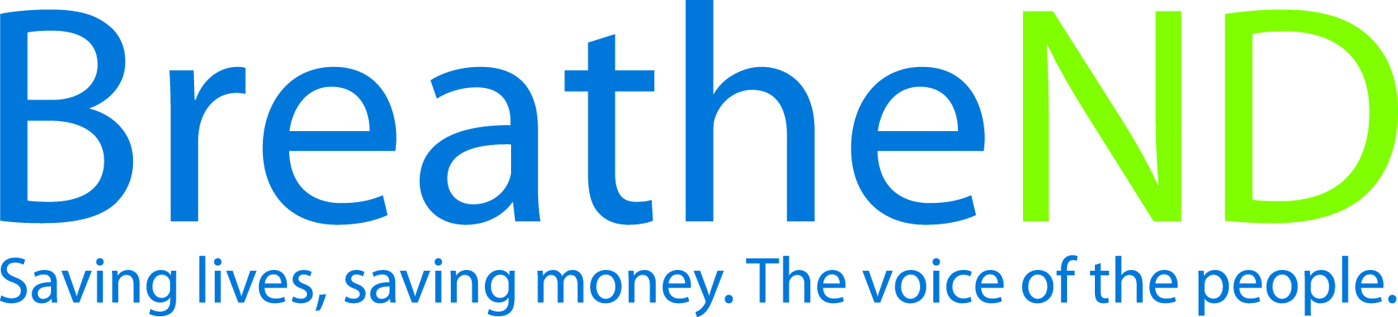

North Dakota Center for Tobacco Prevention
and Control Policy State Work Plan 2016–2018

Initiative: Tax Increase Organization
Date Completed
Goal 1: Prevent Initiation
Goal 3: Promote Quitting
Objective 1: By June 30, 2017, increase the price of cigarettes by a minimum of $2.00 per pack and a corresponding price increase for all other tobacco products, excluding FDA approved Nicotine Replacement Therapy products.
Rationale: Campaign for Tobacco-Free Kids, from projections of research, findings are that each 10% cigarette price increase reduces youth smoking by 6.5%, adult smoking rates by 2% and total consumption by about 4% (adjust down to account for tax evasion effects). The Guide to Community Preventive Services, November, 2012, pg. 1-2 confirms public health effects are proportional to the size of price increase and scale of intervention.” CDC Best Practice for Comprehensive Tobacco Control Programs January 2014 recommends increase the unit price of tobacco products for preventing tobacco use among youth.

Baseline: Current cigarette excise tax is $0.44. The North Dakota cigarette tax was last increased in 1993 and current tax ranking is 48th in the United States. Excise tax on other tobacco products (pipe tobacco and cigars) is 28% on wholesale purchase price. Chewing tobacco and snuff are taxed on weight. Electronic smoking devices are not defined nor taxed as a tobacco product in ND Century Code. Youth smoking prevalence rate is 11.7% (YRBS 2015) and youth smokeless tobacco rate is 10.6% (YRBS 2015). Adult smoking prevalence rate is 19.9% and adult male smokeless tobacco rate is 11.8% (BRFSS 2014). ND American Indian adult smoking rate is 45.7% (BRFSS 2014).
Evaluation: Youth smoking prevalence rate drops to single digits.
Youth smokeless tobacco rate drops to HP2020 goal 6.9% from ND 10.6%. (Source: YRBS 2015)
ND American Indian rate drops from 49% to 47%. (Source: CDC’s State Tobacco Activities Tracking and Evaluation
(STATE) system, Data Highlight Report. Estimates are a combination
of two years of data.)
Minimum price per pack of cigarettes is increased by $2.00 per pack along with a corresponding price increase for other tobacco products.
Adult smoking prevalence rate drops to HP2020 goal of 12% from ND 17.5%. (Source: 2015 Adult Tobacco Survey)

Lead: ND Center for Tobacco Prevention and Control Policy

Strategies:
☐ 1. Conduct surveys of public, legislators, and candidates to determine level of support.
Public Survey:
- Survey instrument written and approved
- Survey conducted
- Results analyzed
- Report written
- Communication/distribution plan written and approved
- Communication plan implemented
Legislative/Candidate Survey:
- Informal survey instrument written
- Formal survey instrument written
- Results analyzed and provided to partners/coalitions
- Communication/distribution plan written
- Communication plan implemented
☐ 2. Develop a policy plan with state and local support (legislative strategy, educational materials including information on all tobacco products, develop and activate coalitions among populations affected by tobacco-related disparities and youth).
- Identify potential partners/coalitions
- Obtain support of proposed policy change from potential partners/coalitions
- Identify potential state agencies as partners
- Identify key policymakers as potential bill co-sponsors, champions and supporters
- Meet with key policymakers on legislative objectives
- Policy plan written and approved by supporting partners/coalitions
- Education materials developed
- Public information materials developed
- Obtain support from state and local agencies and coalitions
- Develop protocols for communication and decision making with partners/coalitions
- Other
☐ 3. Introduction of legislative bill to increase all tobacco prices.
- Monitor interim legislative committees
- Bill language researched
- Bill language drafted
- Recruit legislator(s) to serve as prime sponsor(s)
- Bill language finalized with legislative sponsor(s) and legislative council
- Subsequent sponsors identified and sign on as sponsors
- Bill filed
- Session strategy developed
- Bill is passed, signed by Governor, and becomes law
☐ 4. Introduction of legislative bill to define electronic smoking devices as a tobacco product.
- Monitor Interim Legislative Committees
- Bill language researched
- Bill language drafted
- Recruit Legislator(s) to serve as prime sponsor(s)
- Bill language finalized with legislative sponsor(s) and legislative council
- Subsequent sponsors identified and sign on as sponsors
- Bill filed
- Session strategy developed
- Bill passed, signed by Governor and becomes law
☐ 5. Monitor legislative activity and implement policy plan.
- Identify Legislative Committee assigned for hearings on committee(s) calendar
- Legislative policy/strategies reviewed
- Commitment for action from partners/coalitions
- Identify additional key policymakers
- Educational materials used by advocates are developed and/or refined according to use (legislators/public) based on arguments
- Education provided to legislators, partners/coalitions and public
- Committee hearings attended
- Report and analyze opportunities or concerns identified during advocacy work
- Key legislative council staff contacted for bill information
- State and local agencies, partner/coalitions demonstrate support
- Coordinate and provide testimony
- Communication protocols evaluated and changes made
☐ 6. Evaluation of policy plan after session.
- Conduct SWOT analysis
- Revise policy plan based on results of analysis
☐ 7. Advocate for federal excise tax increase.
- Contacts made with congressional delegation
- Congressional visits made
☐ 8. Continued dialogue with tribal leaders and ND state officials (Governor, Tax Commissioner, Attorney General and Indian Affairs Commissioner Executive Director) for consideration of tribal and state tobacco compacts matching or exceeding the stated price of cigarettes by a minimum amount of $2.00 per pack and a corresponding price increase for all other tobacco products excluding FDA approved Nicotine Replacement Therapy.
- Talking points developed
- Conversations conducted with ND state officials
- Monitor OMB Rev-e-Newsletter for cigarette tax general fund balance
- Monitor Tribal and State Relations Committee (legislative and interim)
- Investigate findings and take action as a result of Committee work
- Meetings held with ND Indian Affairs Commissioner and Standing Rock Chairman or delegated authority
- Meetings held with Three Affiliated Tribes, Turtle Mountain and Spirit Lake Chairman or delegated authority
- Compacts signed

